Layin’ in the Weeds

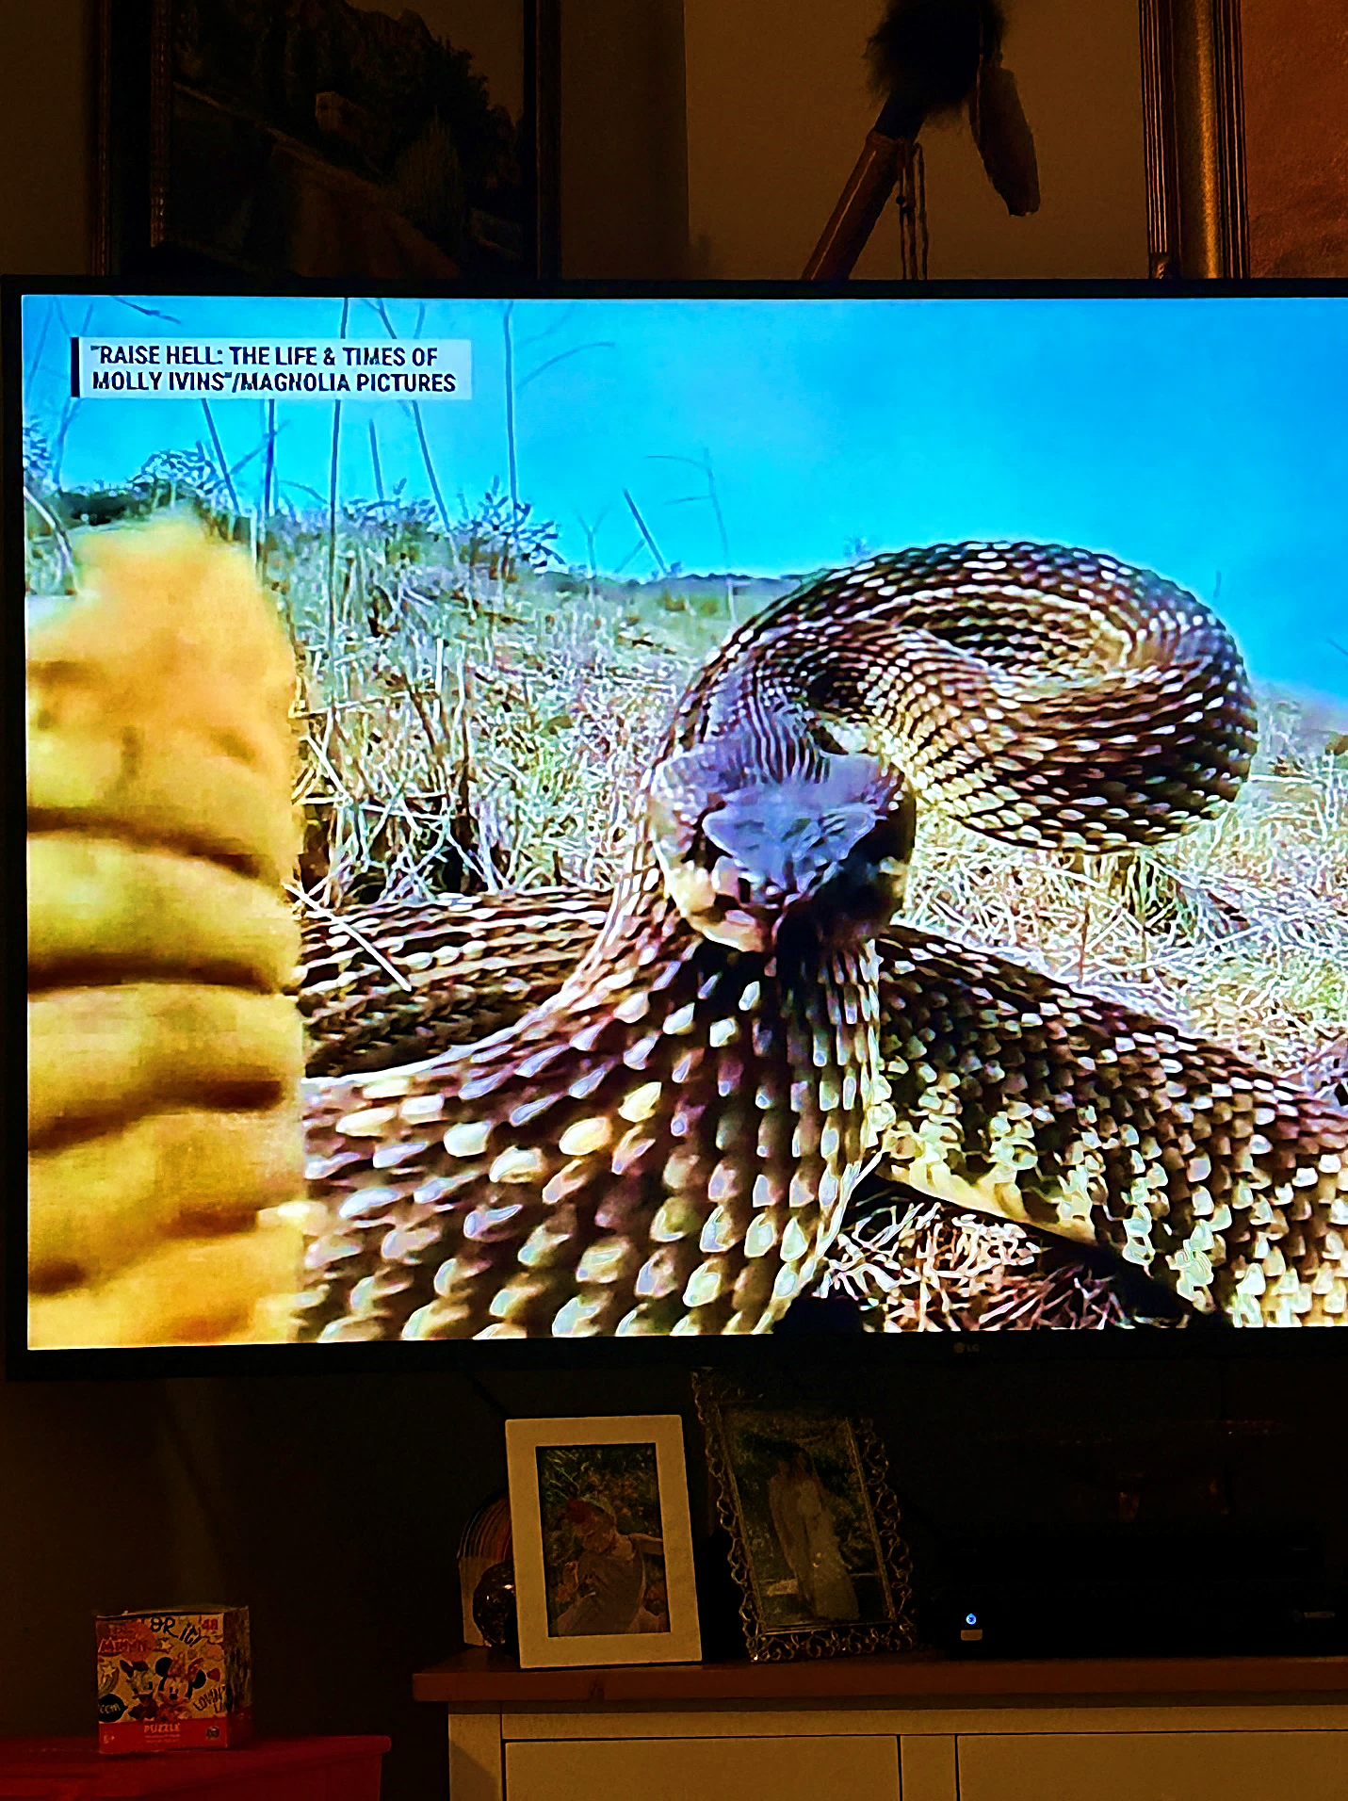

Don Wright

Rhythm in the Word, Volume 15
Home Recordings – 2024

Layin’ in the Weeds
Copyright 2024............................by Don Wright
Lyrics and music for all songs by DON WRIGHT
Vocals, guitars, harmonica, keyboards & mandolin – DON WRIGHT
Background vocals, tambourine & shakers – Carmen Madrid Wright
Recording & sound mixing done in Studio 44 – Los Osos, California

Ezekiel in the valley of dry bones The church is burning
Is told to will the flesh back onto bones Just before the sunrise
That have long since been depleted Dark clouds of woodsmoke
Now this is not his usual line of work Showing against a leaden sky
Prophecies, seeking a vision We couldn’t quite believe
Encouraging faith in the things to come That it was what it was
These are things he is comfortable with Then the flames erupted
This is what he has been called to do Clear and red yellow bright
Bringing dust back to life As real and horrible as could be
Is not within his capabilities he fears And already too fully involved
Why has he been asked to do this? To allow for any hope of salvation
How does such a place as this exist?
It is not for him to know
And it is not for him to question
It is only for him to do
And it will be done From: ‘Letters of Faith’- D. Wright, 2024
“It ain’t that train coming at you
Or anything you’re gonna see”

They say you never hear the sound of the gun that fires the bullet that takes you out. Not sure how they know that. Maybe they asked gunshot victims, “Did you happen to hear that shot ‘fore you got hit?” Doesn’t seem likely but who knows? You get the idea. That thing that changes everything is usually the thing you didn’t see coming. Least I never have. That doesn’t mean you shouldn’t keep an eye out for it anyways though.

LAYIN’ IN THE WEEDS Copyright 2024 by Don Wright

I ain’t here to tell you what to do
But I’ll tell you what I know
You got to watch out for the stuff
That’s crawling ‘round down below
It ain’t that train coming at you
Or anything you’re gonna see
It’s the silent one, the watchful one
Layin’ in the weeds
Well if you don’t hear nothin’ movin’
That’s the time to look around
Watch your step and travel lightly
Keep your eyes on the ground
All this time you might ‘a said
Ain’t nothin’ gonna surprise me
You never counted on the one with the sly smile
Layin’ in the weeds
Maybe you better go back where the streets are paved
And the water comes out of a hose
Leave the huntin’ and the pickin’
And the work of the Lord
To those of us who know
Don’t say I didn’t warn you
About the one waiting patiently
Living in the shadows, moving in the dark
Layin’ in the weeds

So I’m just here to tell you
What I seen and what I know
You got to watch for what is always
Crawlin’ ‘round down below
It ain’t that train you see coming at you
It ain’t anything you’ll see
Yeah it’s the silent one / The watchful one
Layin’ in the weeds
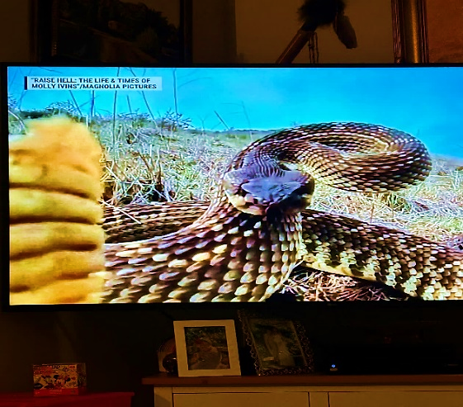
”When you go just leave that door wide open
I’m coming right behind”

They thought the silence would comfort them. That it would be soothing and restful. It wasn’t. It left them feeling anxious. They longed to hear a voice of any kind. Reassuring them that they were in good hands and that they were where they should be. And that there was another step to take. Another place up ahead. Maybe someone was preparing that place just for them. They waited. Becoming more unsettled as the time passed. But there was nothing. For what seemed like days – although there was no point of reference for such an earthly accounting of time... Then He appeared.

SAVE A PLACE FOR ME (I’ll save a place for you) Copyright 2024 by Don Wright

There’s still some coffee in the kitchen
And a bed laid on the floor
There’s nothing I can see that’s left undone
I hope there’s nothing more
There comes a time for moving on
That always has been true
If you get there first save a place for me
I’ll save a place for you

When you punch your ticket on that midnight train
When it comes rolling through
Make sure you save a place for me
‘Cause I’ll be coming too

Now every road we’ve traveled has been a wild ride
I never have come this far without you by my side
And there’s nowhere you could ever go
I wouldn’t follow you to
Where you’re going save a place for me
I’ll save a place for you

If you punch your ticket on that midnight train
When it comes rolling through
Make sure you save a place for me
‘Cause I’ll be coming too

When you go just leave that door wide open
I’m coming right behind
I’m going wherever you think you’re going
You can count on that alright
All is as it should be now, there’s nothing left to do
Just be sure to save a place for me
I’ll save a place for you

If you punch your ticket on that midnight train
When it comes rolling through
Make sure you save a place for me
‘Cause I’ll be coming too

Wherever you’re going save a place for me
I’ll save a place for you
“Where the mighty have fallen and left their remains
To be scattered around by the wind”

I woke up in San Francisco on a rainy morning in October. 1972 I think it was. The garbage trucks were making a lot of noise out in the alley. So I rolled off my mattress on the floor and walked over to the window with a view of Columbus Avenue where it crosses Broadway and drops into downtown. North Beach was always my favorite place in the city. But it was then I knew, even though I was born here, I didn’t belong here anymore. It’s a hard place to hear what the universe is trying to tell you – too many people talking, scheming and the like. I needed to get out where I could see the whole sky, from horizon to horizon, and just listen.

I expect I’ll be back again one day.

LOST IN THE CITY Copyright 2024 by Don Wright

I was lost on the mountain
But I found my way home
I was lost in the wilderness
But I never was alone
Every road that I travelled
Just brought me back here
To the place that I thought that I knew
Now I’m lost in the city
And I don’t know what to do

There were nights bright with laughter
And there were days cold and black
I took what was given
Now you can have it all back
I’ve been lied to and cried to
And saved when I shouldn’t have been
All for reasons unknown
I’m lost in the city
Got no place to go

Out where the wind calls your name
And the rain comes straight down from above
And the darkness you see
Is how it’s supposed to be
Until the rising of the sun

From down in the shadows
Of these towers above
I seek out the warmth and the light
Of an unfaithful sun
Where the mighty have fallen
And left their remains
To be scattered around by the wind
I’m lost in the city
Yeah I’m lost in this city
Lost in the city
Looking for a way out again

Out where the wind calls your name
And the rain comes straight down from above
And the darkness you see
Is how it’s supposed to be
Until the rising of the sun

Now I’m lost in the city
I’m lost in this city
Lost in the city
And looking for the way out again

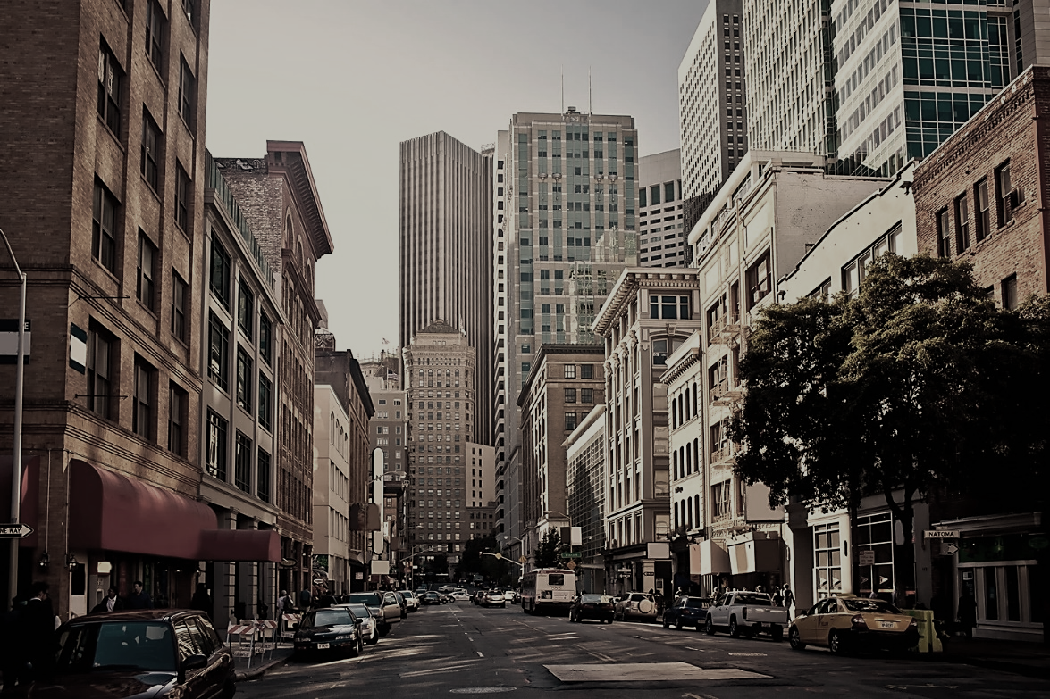
Downtown San Francisco

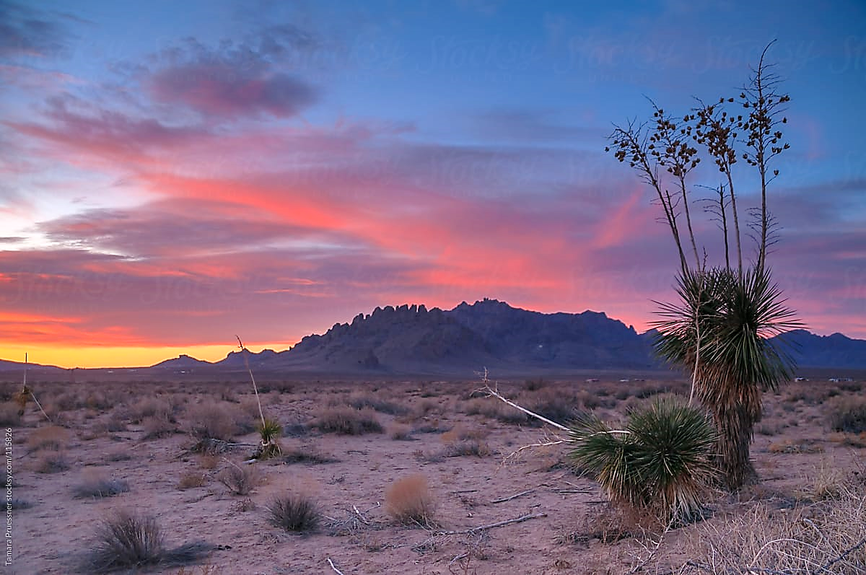
Sonoran Desert, New Mexico
“Can’t outrun the man that I am”

I may not be the best person to manage my affairs. I’m pretty sure there are any number of people who could make better decisions on my behalf than the ones I’ve made. I’m not saying I’m unhappy with who or where I am right now. Just saying there might have been an easier road to getting here. But hey, that’s all behind me now.

Although there’s still some road to travel. Maybe I’ll put an ad in the paper – “Manager needed, no benefits.”

CAN’T HELP MYSELF Copyright 2024 by Don Wright

I can’t help myself, no I can’t let go
Of what was mine just a while ago
I look down that road at the setting sun
Wonder where I’m going and what I’ve done

Now what in the world do you think you see
You don’t know what’s comin’ after me
Buzzards are circling over head
Better keep on movin’
They don’t look well-fed

I can’t stop this feeling
It’s like a storm comin’ in
Can’t outrun the man that I am
Or what all I’ve been
Let’s tell it like it is
I’m gonna jump right in
I just can’t help myself

I think you oughta turn ‘round and walk away
Before this sun goes down today
I believe in the light and the way of the Lord
But under cover of night
Anything can happen and more

Just go your way, I guess I’ll go mine
And we’ll just see what happens in time
But I’ll tell you something
That you can’t deny
You I know I ain’t gonna change
‘Till the day I die

I can’t stop this feeling
It’s like a storm comin’ in
Can’t outrun the man that I am
Or what all I’ve been
Let’s tell it like it is
I’m gonna jump right in
I just can’t help myself

“I bought a couple of suits
And a ten-year-old Cadillac”

Music City. I have a friend in Nashville who always reminds me, “The music business ain’t easy but it is simple.” Well to him I say, “It is simple but it sure as hell ain’t easy.” You can spend an awful lot of time goin’ nowhere in a town like this – even if you got the goods.

When I was a lot younger, I loved moving to a new town and learning how to get around, who to deal with, and settling into a position of comfort with the local culture. Finding a way to get everything I could out of what was offered, seeing if I belonged and establishing a foothold in what might be a future.

Nashville cured me of all that.

THE LIGHTS OF NASHVILLE Copyright 2024 by Don Wright

There was a girl looking out her window at me
As I was walking down the street
In Nashville, Tennessee
She turned that car around and opened the door
And said just get in
Don’t wait too long boy
And don’t make me say it again

She slid on over a little
And I got in behind the wheel
We headed south out of town
As the sun settled down in the fields
She said her name was Melinda
And she wasn’t from around here
I said that’s fine I ain’t either
Let’s just drive and end up somewhere

As the lights of Nashville faded away
I knew what I was leaving behind
But I might be back here someday
It can be lonely and hard on the road
But just as bad in a city so cold
Oh the lights of Nashville
Brighter than any fool’s gold

We tried a couple of towns for awhile
I don’t remember the names
It didn’t last too long
But we had us some fun just the same
She went her way, I went mine
It just wasn’t to be
And I headed back up north
To Nashville Tennessee

I got a job tending bar
And a room with a view of the street
Every day I would knock on doors
Until they’d ask me to leave
I bought a couple of suits
And a ten-year-old Cadillac
I hit the highway going west
And I told myself not to look back

As the lights of Nashville faded away
I knew what I was leaving behind
But I still might be back there someday
It can be lonely and hard on the road
But just as bad in a city so cold
Oh the lights of Nashville
Brighter than any fool’s gold

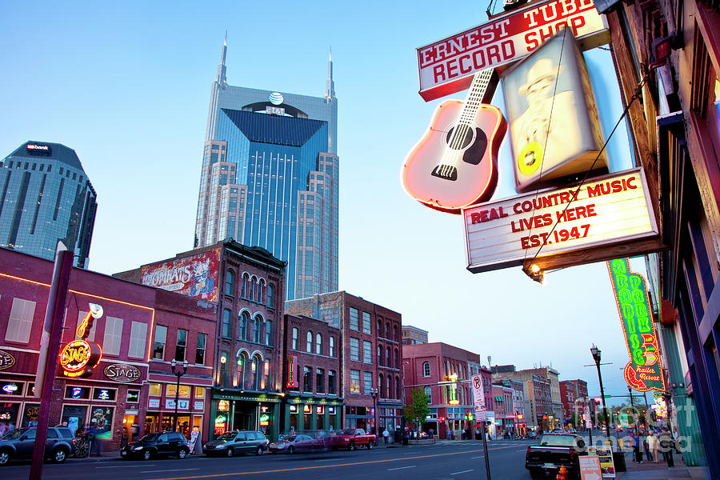
Music City

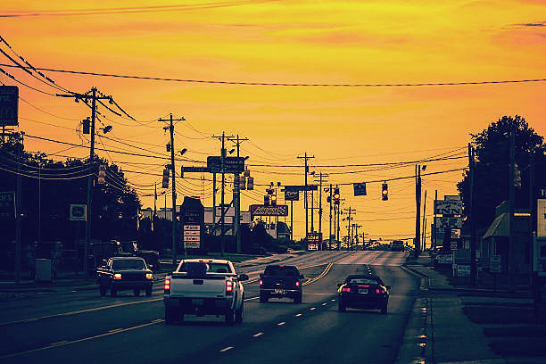
Leaving Nashville

“There’s always something waiting for me”

Sometimes I think I haven’t learned much over the years. I mean, sure, experience gets you some skills in navigating situations you’ve already screwed up in the past, but there’s always something new around the bend that you suddenly realize you’re not prepared for. Life is unpredictable – which is both its beauty and its bane.

There’s really no choice but to keep getting up in the morning and thanking God for our predicament.

LIKE A WHEEL (I Keep Rolling) Copyright 2024 by Don Wright

Like a wheel I keep rollin’
Try to stop me if you can
And like a train
That never leaves the track
I got nothin’ but time on my hands

In my mind
I think I’m better off right now
Than I ever was before
Even if I’m lost
In the middle of the darkest woods
There ain’t nothin’ to fear no more

Oh now,
There’s still something in my head
Rattlin’ around like bones
Every minute of my life
Has been a gift it’s true
Through no doing of my own

There’s no one can tell me different
In this whole wide world
There’s a light beyond what we can see
And a voice beyond what we’ve heard

Like a wheel I keep rollin’
Never looking back behind
There’s always something waiting for me
It’s just up ahead
All I want’s to make it mine

There’s a light beyond what we can see
And a voice beyond what we’ve heard

Like a wheel I keep rollin’
On and on and on and on
Like a wheel I just keep rollin’
On and on and on

”I tried to break free but I keep coming back”
I met a kid in county jail – nineteen, twenty years old – he killed another kid about the same age because he caught him with his girlfriend. Shot him five or six times and was going to plead self-defense. I asked him why he shot him so many times and he told me it felt good, so he kept on pulling the trigger.

Turns out, as a child, all he ever knew, growing up, was poverty, violence, drunkenness, meanness. Now, I know other people who grew up with all that and they didn’t kill nobody. Never did anything even close to that bad or anything bad at all. Once that is said, some people might say (in fact, do say) that everyone has a choice, regardless of their environment. I don’t think it’s that simple. I wish it was. I don’t think everyone has the tools – either built in or learned – to make that choice.

I ain’t saying it’s not his fault – he may be in prison still or may have got out and killed again – I’m just saying there’s another explanation beyond saying that he had everything he needed to make the right choice and decided to do this anyway.

It just ain’t that simple.

BAD BLOOD Copyright 2024 by Don Wright
I come from country where the wind is hard
It’s a struggle just to survive
You lose all you got if it ain’t tied down
Any day you could lose your life
I been runnin’ through the bushes on the riverbank
Stayin’ one step ahead of the flood
The old folks shrug their shoulders
They just shake their heads
They say it’s all on account of bad blood
Back up in the hills on that rocky ground
Or out where the river bends
It’s all about the same as far I can see
Bad luck and trouble never end
I tried to break free but I keep coming back
Like to think I’ve changed but I guess not enough
Now you might say
It’s nobody’s fault but my own
But I think it’s on account of bad blood
Now I’ve been told these stories
All my life, more than a time or two
Way back down the line there were dark dark days
And I guess it just carried through
Ain’t no one can tell from one day to the next
What will become of us
But the truth is you can’t step away from yourself
When you’re washed through and through in bad blood
I didn’t ask to be born
I guess no on one does
Who knows how that works anyway
Got no reason to wish for some other life
We’re just lucky to get through a day
Yeah I could go anywhere but it’d still be me
And if that makes me the prodigal son
It’s all the more reason I’ll be stayin’ right here
You just can’t get away from bad blood
No there ain’t no escape from bad blood

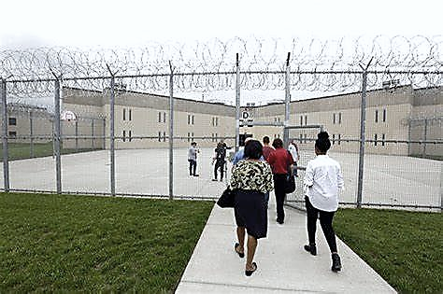

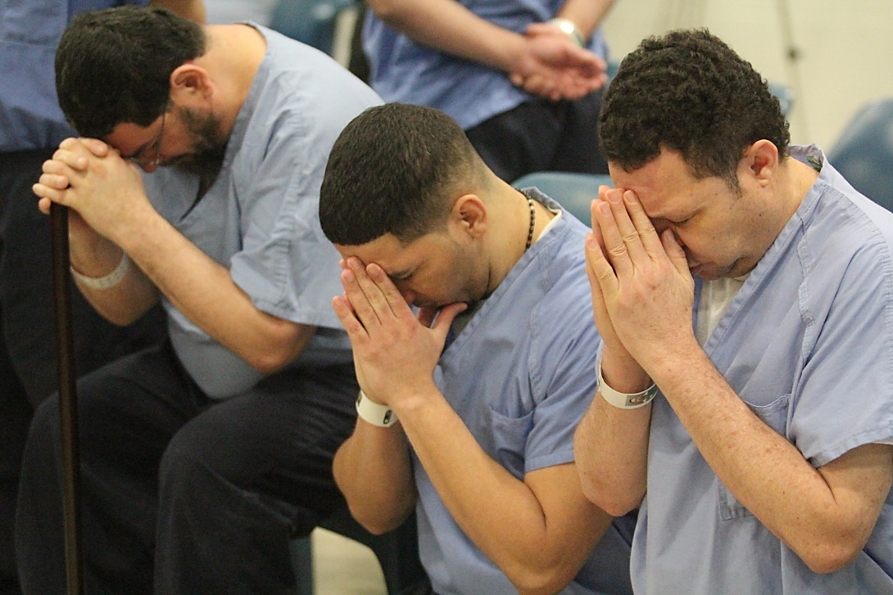
“I always worried ‘bout the fire and the flood
I think they’re comin’ still”

I wrote a song some time back titled, “I Don’t Know What Love Is.” I said something to the effect that I know what it feels like but don’t know what it is, really. Well, I know what it feels like when it’s gone, for sure. Still don’t know what it IS though.

AS LONG AS LOVE IS GONE Copyright 2024 by Don Wright

You know that old saying
Well that old saying is true
What goes ’round comes ‘round
Then goes ‘round again
No matter what you do
If you ever wondered
Where the time has gone
Or where the sun goes to hide from the moon
Just sit right there and wait awhile
It’ll be comin’ back ‘round soon
If it feels like you’ve been here before
You ain’t wrong I can’t lie anymore
There ain’t nothin’ gonna change
As long as love is gone

We’ve had our ups
And we’ve had our downs
Can’t always tell ‘em apart
There’s nothing simple
And nothing’s ever clear
In matters of the heart
The things that you always counted on
Are just the things that will let you down
Don’t you know that if you
Put all your faith in love
You got nothin’ when that love runs out
So keep something just for yourself
That’s always something
That will serve you well
And it’s never gonna change
As long as love is gone

There’s fire down in the valley
It’s raining up on the hill
I always worried ‘bout
The fire and the flood
I think they’re comin’ still
Nobody tells me that
It’s all gonna be alright in the end anymore
Maybe there’s a reason I haven’t been told
What I was sent here for
Or maybe it’s just too late
For anything we could do or say
Nothing’s ever gonna change
As long as love is gone
“If you wade out in the water
Don’t expect to come back the same”

A kind word or two can go a long way towards making a difference in someone’s life. There’s more to it than just being polite. I think it’s important to try to see each person’s unique qualities and let them know they’re appreciated. Give them a simple compliment.

It doesn’t even have to be true.

‘ROUND THIS RIVER TOWN Copyright 2024 by Don Wright

He stood down on the corner
With his suitcase in his hand
Turned my head for just a second
And never saw him again

I believe in the miracle
Of every song that is sung
Ain’t one better than the other
When it’s all said and done

I remember the stories
Of a man who was passing through
He touched everyone he encountered
With just the gift of a word or two

If you wade out in the water
Don’t expect to come back the same
Let it wash over all your troubles
Let the spirit take you away

If you ever get down this way
Look me up and I’ll take you ‘round
‘Round this river town

What you feel in the morning
Ain’t the same way you feel at night
After you’ve seen what I’ve seen
And done what I’ve done
You tell me that I ain’t right

We got our own way of walkin’
We got our own way of talkin’ too
There ain’t no one of us like another
You can judge us by what we do

If you ever get down this way
Look me up and I’ll take you ‘round
‘Round this river town
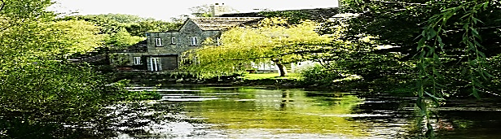
“Some men dream, some just sleep”

We are not objects moving about on a game board of our own design. Take a slow, deep breath and fill up your lungs and imagine everything that is happening in that miracle of a creation we call our body. Cells being oxygenated, heart refreshed, blood circulating. Good God, we take such inexplicable complexity for granted! And it’s all given to us so that we may have the opportunity to listen to what the universe has to tell us.

But do we? Quiet your mind and let the messages come in. Be patient. They’re always there. Waiting for you to open the door.

IT’S UP TO YOU TO WRITE THE END Copyright 2024 by Don Wright

Come to me, take my hand
Pull me from this place I’m in
Watch your step
There’s danger around every turn
Every time I rise I fall again

Some men dream, some just sleep
But it all ends up the same
Come and lay down by my side
And close your eyes
Be still and listen to the rain

And if you hear what sounds like
A story being told
It’s up to you to write the end

Come to me, lead the way
I will follow close behind
My trust in the road ahead
Has never been betrayed
I owe to you all that is mine

Where shadows fall
You know there must be light
For every pleasure there is pain
If we’re to be given
What we seek when it is time
Just listen close
To the voice you keep inside

And if you hear what sounds like
Your story being told
It’s up to you to write the end

If you’re delivered
Undone messages of hope
It’s up to you to write the end

۝

“Even trouble has a way
Of turning out to be a blessing in disguise”

You got any idea of what’s gonna happen tomorrow? Sure you do. Doesn’t mean it’s going to though, does it. I’ve talked about hope and how it’s the only emotion I can think of that separates us from all our other animal brethren. I think it’s the primary thing that makes us human. Sure, we have other skills, physical advantages, bigger brains, but we ASPIRE. We yearn.

Question is, does this elevate us? Or condemn us?

IN THE DARKEST HOUR Copyright 2024 by Don Wright

There’s a crimson sky at the break of day
Looks like trouble coming in
Looks like it’s gonna stay
I can feel it in my bones
And I can see it rising up above the morning light

We may think our fate is in our own hands
But what happens next
Is not always what we plan
I’ll tell you when it’s over
If it’s anything like what I had in mind

Stay here by my side / We’ll keep hope alive
Even the smallest flame burns bright
In the darkest hour

Now there’s a simple reason
This is the way it is
Everything comes ‘round to where it begins
Even trouble has a way
Of turning out to be a blessing in disguise

So get behind the wheel
We’ll see where this highway goes
Wherever that may be we will never know
Until we turn our faces to the wind
Get down the road and leave it all behind

Stay here by my side / We’ll keep hope alive
Even the smallest flame burns bright
In the darkest hour
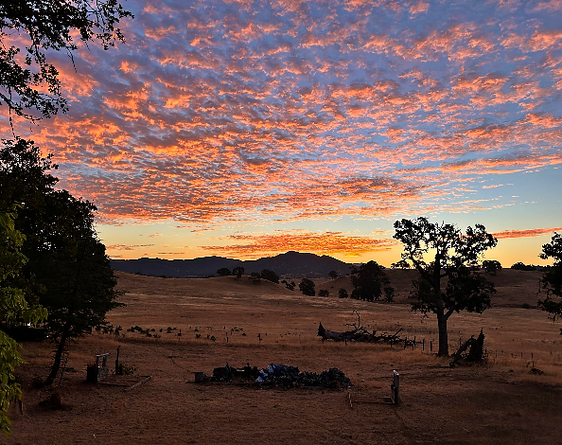
“When it comes to this hunger
There’s no wrong and there’s no right”

When the reality is even better than the dream, well ain’t that a most fortunate day! But when two people have the same obsession, the reality can spiral out of control. One or the other may have to pull back before they both go down in flames. One never knows what’s going to be created when the dream materializes.

One just never really knows.

EVERY ONCE IN AWHILE Copyright 2024 by Don Wright

Lord we been together a long, long time
And it’s been like one big roller coaster ride
Now you might think that sounds exciting
Yeah there’s been some
But every once in awhile
I think I want to stop this thing and get off

Every once in awhile
Something in the back of my mind
Tells me we can’t keep
Runnin’ like we’re doing day and night
Or maybe once more ‘round
And I guess I’ll just hang on tight
Yeah it comes and goes every once in awhile

Hard is the way / Sweet is the sound
And everything that goes up
We all know must come down
You were mine
And I always have been yours
Every once in awhile
I wonder how love has endured

Every once in awhile
There’s some light shining through the rain
And the world is dark
Until you pass this way again
When it comes to this hunger
There’s no wrong and there’s no right
But I can’t help but think there’s a price to pay
Every once in awhile

Oh if I could just lay down
On this bed and close my eyes
And dream of you every once in awhile
I’d dream of you
Every once in awhile
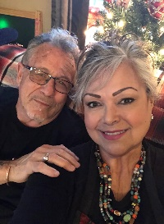
~~~~ Thoughts ~~~~

“Prepare yourself for the afterlife
And you’ll be a better person
Even if there isn’t one” D.W. (Message received as I awoke one morning recently)
----
We have to be just smart enough to know when to stop asking questions.
Because eventually we get to the question for which there is no answer we can know. That’s not to say there isn’t one – an answer - but we cannot know it. To keep asking it can only lead to frustration, to anger, or to despair. We become despondent. This can serve no good purpose.
The question is - Are we something beyond what is contained within our bodies? That thing that communicates with the universal force, the creator. Is it a thing that will somehow live on after our body expires? Or is it only fueled by the beating of our hearts, the blood in our veins and the electricity in our brains? The physical reality of what we are is a miracle beyond our comprehension. Can we really expect there to be more to us than that?
I don’t know. We can’t know. We don’t even know if there is anything TO know.
----
The violin. I don’t understand how anyone plays this instrument. It doesn’t have any frets! How do they find that exact spot? And so quickly? I mean I don’t hear any sliding up to or back to a particular note. It’s just one more thing I don’t understand, like, of course, Time. The human body. Gravity.

Thank you to all the fiddlers and violinists for contributing to my confusion.
----

All men are created equal
But it’s a woman above all
Who carries us
Who delivers us
Knowing the pain
And the sacrifice it requires
That’s what a woman does
She does the hardest part
When it comes to raising a child
Some are better at it than others
Both men and women
But that test only comes
After nine miraculous months
While God works His magic
At the expense of the woman
And she answers the call

We take pride in what we’ve done
But our contribution
Is of little consequence
It is short-lived
We are driven to it
Like the moon pulls in the tide
And then our work is done
But hers has only begun
All men are created equal
And all men are equally grateful
That we are not asked to do this
To submit ourselves to such agony
To put our lives on the line
Let’s not forget
What is taken most for granted
Not Father Time, but Mother Earth

----
Who has the right to the land?
The first one here or the last one standing?
Practically speaking, I guess you’d have to say the latter. But I sure wouldn’t call it ‘right’. The land will always be here. We won’t. The first time something crawled up out of the water, sucking for air, and trying to understand how to survive in this new world, they would soon be defending their right to do so. God created everything, including evolution, and gave Man free will. That was His first mistake because Man wants what’s his and he wants what isn’t. And he’s his own mistake.

Someone Shot the Bank Manager (cont. from Volume 13) –

Brie Louise McDaniel lay in her childhood bed, upstairs in the house on North Pearl Street, the family home just down the street from the Grayson’s. Her father Jerome had been called from the Modern Dress Shop when she had fainted in the back hallway and been carried to the divan in the office. He had his driver carry her out and lay her down in the back seat of the Cadillac sedan, still semi-conscious and in no hurry to be otherwise, and drove her home.

Her mother Caroline tip-toed through the bedroom door with a warm tea and brandy and laid it down quietly on the nightstand. She brushed her daughter’s hair back off of her face carefully, not wanting to wake her but Brie’s eyes opened and she just sighed, “Mama.” “Oh baby, have a sip of this when you can. Louie Grayson is downstairs, he brought flowers.” “I... can’t right now,” she said. Then she rolled over, suddenly recalling everything, buried her face in the chenille bedspread and bawled and gasped for breath.

Caroline went back down and lied to Louie, telling him that her daughter was still sleeping and thanked him for the flowers. Louie was sitting in the vestibule, in a straight-backed chair, still holding the vase of flowers. “I’ll take those, dear, and set them in her room so it’ll be the first thing she sees when she wakes up.” He handed her the vase and said, “Mama wanted to send over a Rhubarb but I told her I thought it was too soon for such a enjoyable thing as a pie just yet. So, I just thought the flowers would be the right thing for now.” He was trying to think of something more meaningful to say but was lost for words and sputtered out, “You know, I thought the world of Teddy and I wasn’t one who was against their being together and all. I just wanted Brie to be happy.” He walked right up to the edge of saying a whole lot more about his feelings for Brie but stopped himself and thanked Caroline. “Say hello to your mama for me and thank her for the gesture. You take care, Louie.” With that, he let himself out and headed on foot, down to the river.

The Mississippi river runs through Natchez like blood runs in the veins of a living, breathing animal. The river means everything to the city. The city means nothing to the river. Louie had walked every inch of both banks as a child and all his life since. Some years back, he had discovered a young girl living in a dugout part of the bank and after many attempts, had befriended her. He had tried to get her to come into town and get cleaned up, get a room in a boarding house and get back to a normal life. She had refused. She told him this is where she preferred to live. He brought her food and clothing and would visit her from time to time.
He walked to the end of Madison Street and dropped down to a trail he knew along the riverbank. The afternoon sun was lowering itself into the mist as he got closer to the familiar dugout in the bank. He felt the need to just sit with his friend and tell her some of the things he was feeling. He really felt he had no one else to talk to. As he left the trail to walk the short distance up to the dugout in the bank, he could see someone sitting on the ground in front of the entrance. It was Claude McDaniel, Brie’s older brother, out of uniform and drinking from a bottle of something.
(to be continued – hopefully in Volume 16)
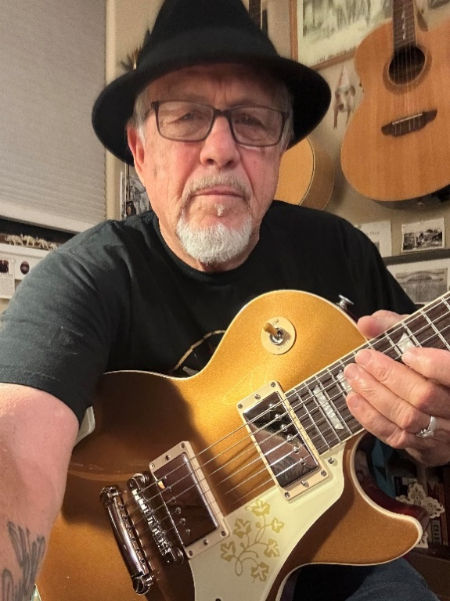

Track List
1 – Layin’ in the Weeds.................................................4:21
2 - Save a Place for Me.................................................4:22
3 - Lost in the City....................................................4:07
4 - Can’t Help Myself...................................................4:27
5 - The Lights of Nashville.............................................5:08
6 - Like a Wheel (I Keep Rollin’).......................................3:40
7 - Bad Blood...........................................................4:02
8 - As Long as Love is Gone.............................................4:04
9 - ‘Round this River Town..............................................3:54
10 – It’s Up to You to Write the End....................................4:06
11 – In the Darkest Hour................................................3:12
12 – Every Once in a While..............................................3:07
Rhythm in the Word, Copyright 2024 by Don Wright
donwrightmusic.com

