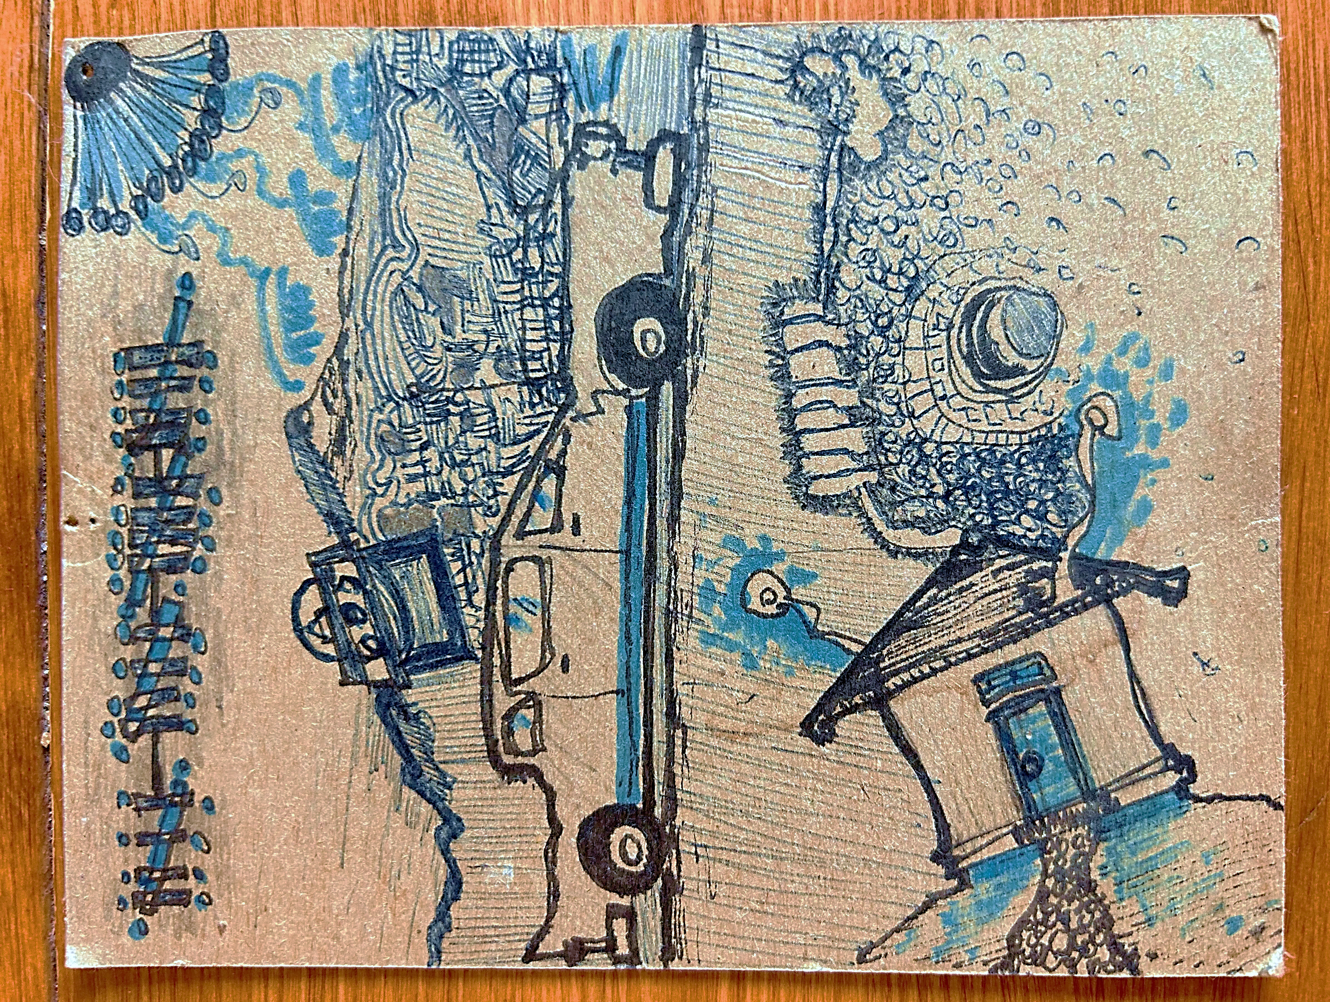
real dreams – Don Wright

Rhythm in the Word - Volume 14

Home Recordings - 2024
÷ ÷ ÷ ÷ r e a l d r e a m s ÷ ÷ ÷ ÷
Copyright 2024----------------------------by Don Wright

Lyrics and music for all songs by DON WRIGHT
Vocals, guitars, harmonica, keyboards & mandolin – DON WRIGHT
Background vocals, tambourine & shakers – Carmen Madrid Wright
Recording & sound mixing done in Studio44 – Los Osos, California

Sometimes I can’t tell if I’m awake or not. Truth be told, sometimes it doesn’t matter. Once in a while, I wake up as I’m dreaming but I’m still asleep. I’ve had scary dreams, embarrassing dreams, sexual dreams, dreams of heaven and dreams of hell. I had a dream when I was five years old that I still remember, of a bear attacking my father, and I had a dream last night that disappeared the moment I woke up. I used to dream of flying but I haven’t in a long time and I miss that. I’ve dreamed of money but that’s always disappointing. There are people and places in my dreams that I recognize... but I’ve never seen them or been there before. I dreamed a few of the songs on this album and once I dreamed of a half-dog, half-horse that lived in the Taj Mahal with Elizabeth Taylor. Well yeah, that’s a little strange, but...

I know a man who doesn’t dream. Never has. Now that’s strange. D.W. Oct. 2023
” Saw some things I didn’t want to see”
Homecomings never have a predictable outcome. We drift away and drift back. Some things remain the same, many things have changed. We have changed, certainly. Are we there to recapture some lost sense of ourselves? Did we not find anything more rewarding in our travels? Are we here to stay? Or are we here to find out if this really is home?
Sometimes I think the lucky ones are the ones who leave and never return. Or maybe the ones most fortunate are they who never leave.

LONG-LOST SON Copyright 2024 by Don Wright

There’s a cabin with a kerosene light
Out in California tonight
I’m going back to where I’m from
Think my runnin’ ‘round days are done
I sure hope they remember their long-lost son

I’ve been walking these city streets
So long / They finally got the best of me
It took a while but now I know
Where I belong and where I got to go
I just hope they remember their long-lost son

I got a lot of soul searchin’ to do
Had to do it a time or two
Saw some things I didn’t want to see
Like how those I left behind saw me
Will they greet me now with open arms
Or even recognize what I’ve become
Oh Lord do you remember your long-lost son

I got the road rollin’ under me
Across the state line I’m flyin’
Up into the San Joaquin
And out across these hills in the foggy night
I wonder if they’ll remember their long-lost son

There’s a cabin with a kerosene light
Up ahead in the California night
‘Bout an hour before the break of day
Got no idea what I might say
Hey, here I am
Do you remember your long-lost son

Now I feel the gravel rollin’ under my tires
I see people piling out from inside
Wonderin’ if this is who they think they see
Oh we thought that he never would be
Coming back anywhere ‘round here
He looks like somethin’ that the cat drug in
But we’ll be damn if it ain’t our long-lost son
Oh Lord do you remember your long-lost son

...You can’t tell which way’s down unless you jump”

The earth is spinning at about a thousand miles an hour. It also is traveling in its orbit around the sun at about 67,000 miles an hour. At that speed, it takes us a year to travel around the sun. How many hours are there in a year? Multiply that times 67,00 and you’ll get an idea of how far we travel and of the size of our solar system. Feels to me to be unfathomably huge. Additionally, the other eight planets are doing the same with all their little moons happily spinning around them as we all keep flying along at a speed beyond our comprehension... And we’re no more than a speck in the universe. A speck.

Scientists, of course, can tell us how this all works but, like I’ve said before, they can’t tell us why. I’ve come to think that it’s not because they can’t figure out the why. It’s because there is no why to be found. It just IS. As we just ARE. So, we can stop worrying about WHY we’re here and just BE.

WHEN THE MOUNTAINS FALL Copyright 2024 by Don Wright

When the mountains fall and the sun goes dark
Comes the fear we always had
Of the end of things, the great unknown
I’m glad I won’t be around for that

That’s down the road way off I’m sure
Something none of us will see
But we know it’s comin’ and I think that’s why
We’re so troubled and mystified
And a little uneasy / A little uneasy

Time will tell like it always does
But it never has much to say
It whispers in your ear
Words you don’t understand
Then turns and walks away

Now you tell me that there is a God above
I know there’s a mother down here
They seem pretty damn indifferent alright
But they’re working behind the scenes
I don’t think we’d make it a day otherwise
We wouldn’t make it a day otherwise

I’d rather be lost on the river
And never know what’s around the corner
Or where it ends
Yeah I’d rather be gone, gone a long time
Than hear the sound of the last wave
That breaks on the sand

You’re worried about your place in line
You’re not as good but you’re better than some
You’re standing out on a balcony
And you can’t tell which way’s down
Unless you jump

Now everyone’s got a story to tell
Well they better get to telling it soon
There’s a toll to be given at the end of the day
And you better believe it’s true
It ain’t about the money in your pocket
Your money’s no good here

I’d rather be lost on the river
And never know what’s around the corner
Or where it ends
Yeah I’d rather be gone, gone a long time
Than hear the sound of the last wave
That breaks on the sand

When the mountains fall
And they surely will
It won’t mean a thing to you and me
I don’t want to know how it feels at the end
I wouldn’t want to be
A fly on the wall
For eternity
Eternity


“The best lack all conviction. While the worst are full of passionate intensity.” W.B. Yeats, The Second Coming
” I lit every lamp and turned every handle
And signed every letter in blood”

When I dream (whether sleeping or awake) of my ideal place to live, I see narrow dirt streets, low, flat-roofed houses, a couple of flickering streetlights, a grocery store and a gas station, long empty streets that lead out into the farming fields beyond, and neighbors who mind their own business.

I BUILT MY OWN CITY Copyright 2024 by Don Wright

I built my own city
And filled it with people I admire
A couple hundred misfits
With a price on their head
A poet and a hitman for hire

I paved the streets with stones from the river
And the boulevards ran long
Out into the desert where the chollas bloom
And the desert birds sing their song

I built every house without nails
And covered them over with mud
I lit every lamp and turned every handle
And signed every letter in blood

I built my own city
I built what I saw in my dreams
The big empty plazas
In the light of the moon
Wind blowing through the cottonwood trees

Now when I drive through town
I am humbled
By what I know lies behind every door
Visions of wonder, prayers of the faithful
Healing coming up from the floor

Yeah it all turned out like I saw it
Like I saw it in those dreams of mine
I built it all from nothin’ with my own hands
And it unburdened my mind

Wait ‘till that moon comes rising
And the streets turn the color of gold
I’ll go to the top of the hill
To watch over my creation
And everyone will know

I built my own city
I built what I saw in my dreams
The big empty plazas
In the light of the moon
And the wind blowing through the cottonwood trees
” Where the light shines still from your room”

Days end. Roads end. Love ends. Everything ends. It doesn’t make the day that came and went or the road you travelled, or the love you shared, any less than what it was. It’s just the end of a chapter and time for the next. We shouldn’t look upon the completion of any time well-spent as lamentable. Let it not diminish what has transpired – the gift of another day, the journey from here to there, or the miracle and mystery of love. It all ends... but that’s not the moment to remember.

I will say though, this is easier advice to give than to take.

THE END OF THE STREET Copyright 2024 by Don Wright

Down at the end of the street
Where there’s nowhere left to turn
You can find me there
Writing down these words
If you get this letter tonight
Think of me one last time
I couldn’t stay and I know
You weren’t ready to leave

Down at the end of the street
Where the light shines still from your room
I may linger here for awhile
Lost in the memory of you
I only came to say ‘so long’
And hope that you’ll always be
Just the way I remember you
Here at the end of the street

I guess our time was never meant to last
Any more than what it did
And I guess that’s the reason
We shouldn’t even ask what went wrong
With what was right / Or even what it is

There’s one more thing to be said
Then I’ll be on my way
If you should see me down the road
And wonder what to say
Just wave your hand and smile that smile
That I remember so well
And we’ll both know
There’s no need to look back or regret

We had our time, though not enough
It will have to be
Those hours that we spent
In love at the end of the street
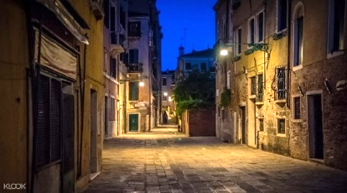
...” you’ve seen the whole wide world now
Yeah I’ve seen it too”

I’ve talked about not having a place I felt a kinship with (‘I Ain’t From Nowhere’, Volume 1) but many people do and I envy them that. I even envy those that never leave that place to explore other lands and cultures. ‘Come on home’.

COME ON HOME (Take a Load off Your Mind) Copyright 2024 by Don Wright

It’s time to cross the road
To get to the other side
Time to come on home
Take a load off your mind
You got time to get on board, put up your feet
Get out of the wind and the cold
And off the street

Come on home where the fires are burning
Come on back to where you’re from
It’ll be just like you ain’t never been gone
Come on home and take a load off your mind

It’s time to slide into the middle
Of a Sunday afternoon
There ain’t no beginning, ain’t no end
No reason to refuse
Anything that you’re offered
Or anything that comes ‘round
Don’t worry ‘bout fallin’
We’re already on the ground

Come on home where the fires are burning
Leave all your city worries behind
There’s still a light in your window and an open door
Come on home and take a load off your mind

Well you’ve seen the whole wide world now
Yeah I’ve seen it too
Ain’t it funny when you come back here
To the place you knew
There’s a whole ‘nother way
To think about everything
Ain’t nothing different but all of it’s changed

Yeah come on home where the fires are burning
Have a look at what you left behind
Just close your eyes and let the world keep turnin’
Come on home and take a load off your mind

Yeah come on home where the fires are burning
Come on back to where you’re from
It’ll be just like you ain’t never been gone
Come on home and take a load off your mind

” All it took was you
To make a house a home”
She didn’t even try. She just had that way about her. And her way with me. We’re not all so fortunate as to finding someone to love and when we do, then we wish for even more – we hope we can have them around for as much time as there is to be had. But there’s only so much fortune we’re allowed. I prayed, and prayed again, that she would never leave. And I prayed so hard, I guess... she never did.

ANYBODY LIKE YOU Copyright 2024 by Don Wright

This old house ain’t never seen
Anybody like you, no it’s been
A long long time since anyone
Has come around
And done the things that you done

You just open a window
Let the light shine in
And I feel like I been born again
All it took was you
To make a house a home
I don’t believe I’ve ever known
Anybody like you

See that moon shining down
Lighting my way tonight
Walk right down to the river’s edge
And thank the Lord you’re still by my side

I’ve driven down most every road
I start to believe every story I told
I left all hope so far behind
There ain’t no way I ever thought I’d find
Anybody like you

I walk the floor of every room
And I feel you walking with me too
It’s been a while now since you been gone
But time can roll on and on and on
And there’ll never be
Anybody like you

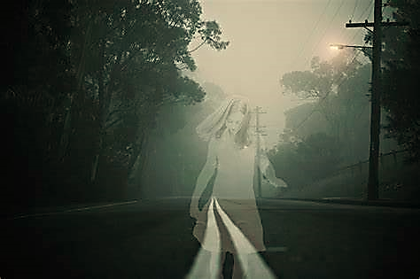
Friend of mine stopped by the other day. Pulled up a chair and poured himself a drink. Mexican brandy. That’s all I carry. Started right off telling me a story about a mutual acquaintance of ours who died some fifty years ago at the age of twenty-three.

Said they were climbing rocks up to a waterfall, south of Big Sur, when he slipped and almost fell to his demise (him, not our friend). Right about here, he pours himself another drink. Says his whole life passed before him, just like they say it does on such occasions.

He had reached up with a little jump, to grab the next handhold he saw, and missed it. Gravity took over and the inevitable seemed, well, suddenly inevitable. But he apparently managed to swing himself around somehow and slammed himself backwards into the rock instead of falling.

He pours himself another drink and asks me do I recall ever hearing about this particular adventure of theirs. I told him I remember Bob telling me about a trip up the coast about that time, but didn’t remember him mentioning anything about a near-death experience for either of them.

Well, he says, and (of course) pours himself another brandy, he didn’t tell you about that part because he was already in the pool above the waterfall, skinny-dippin’ and getting high and the miraculousness (his word) of what had happened probably didn’t even register when I told him about it.

OK, why don’t you pour yourself another and tell me what this all about, I said.

Well, I had a dream last night. Bob came to the house and we talked.

I poured myself a drink.

In the dream, he told me I never made it up over the waterfall to tell him anything. After some time, he grew concerned, got out of the water and walked over to the edge of the rocks where he was expecting me to appear. He said he looked down to the base of the cliff, where the trail ended and there I lay, deader ‘n shit, broken neck, blood dribblin’ outta the corner of my mouth. What do you make of that, he asks me.

Well, it’s a dream. I don’t make much of anything of it, I told him. Dreams are just your brain trying to think without you. Never know what it’s going to mash together and roll out.

As you might figure, at this point we both decided to go ahead and pour ourselves another. Then he asks me if I think maybe he’s been dead all this time (himself). And if everything from that point has just been a dream or something other than what we perceive as reality. Something along those lines.

Listen numb nuts, what I think is, you should go home, put on a pot of coffee and DON’T GO TO SLEEP! That’s what I told him. And I hope that’s what he did.

The day bled into night. I did my first couple hours of sleep on the couch with the TV running, then woke up and went to bed. And wouldn’t you know but that I had a dream. And can’t you imagine who might have been in it.

I’m sitting on a grassy hillside in a park in San Francisco, with a view of the bay. The sun’s going
down and the fog’s rolling in. Bob comes off the sidewalk from down below and walks straight up the
hill towards me, waving his hand in a casual greeting. He sits down beside me and just looks out to
the sunset. As always, he’s frozen in time. Here I am fifty years older and he’s still twenty-three.

I’m about to tell him how good it is to see him when he turns his head, looks me right in the eye and
says, very matter-of-factly, he says, “You’re dead too.”

(‘Someone Shot the Bank Manager’ will return with Volume 15, possibly in November 2024)
” He fell asleep and dreamed of water
And of a girl he’d left behind”
Once you’ve heard a mourning dove serenading the sun down, you understand the crushing, undeniable beauty of sadness and loss. And how there is no hope unless there is suffering. They rely on each other. Like death and rebirth. Like acceptance and regret. Or like dreams and reality.

MAKE MY TROUBLES DISAPPEAR (She) Copyright 2024 by Don Wright
Under the envelope of darkness
Down from the hills without a sound
He rode in spent and unpacked his bedroll
And stayed out on the edge of town

He fell asleep and dreamed of water
And of a girl he’d left behind
The stars spread out across the heavens
Until the early morning light

When he woke, the smell of lilac
Brought him slowly from his sleep
She softly kissed both of his eyes awake
And laid her hand upon his cheek

She said I knew you’d be coming back this way
She just smiled and shook her head
What is it that you need this time
Before you ride away again

Take your pail down to the river
Fill it up and bring it here
Pour it over me onto the ground
Make all my troubles disappear

She started off in that direction
Then she looked back at him and waved
He saw her drop down to the water
But not return still to this day

He saddled up and rode off once again
Across a sad and dusty plain
No matter how many times he sees her
The dream always ends up the same

Take your pail down to the river
Fill it up and bring it here
Pour it over me onto the ground
Make all my troubles disappear

” In my mind nothing’s ever
Settled once and for all”

Once in a great while, I have taken yes for an answer. Not often enough. It’s funny how overthinking leads to underperforming. Every self-fulfilling prophecy starts with that.

AS I LAY DOWN WITH YOU TONIGHT Copyright 2024 by Don Wright

I got the sun shining on my face
The wind at my back
Everybody tells me
Nothing could be better than where I’m at
But I remember
How fast things change sometimes
As I lay down with you tonight

There’s something coming ‘round the bend
Or it always feels that way
I can’t help but think about
All the times I walked away
In my mind nothing’s ever
Settled once and for all
As I lay down with you tonight

From your window I can see the sun
Rising like a melody
My mind starts searching for some place to run
What the hell is wrong with me

I don’t need a fortune teller
To tell me what happens next
Everything is going right
So it ain’t gonna be hard to guess
Why in the world would I want to do
Anything else but this
Just lay down with you tonight

Every time I see an open door
I just go on and walk right in
I couldn’t tell you what I’m looking for
Don’t even know where to begin

Maybe you already know me well
Or maybe well enough to know
Something’s bound to run out in front us
If we keep driving down this road
It never fails but I’ll take a chance
If you’re willing to
As I lay down with you tonight

I know I haven’t given you
Much reason to want me here
As I lay down with you tonight?
” I’ll ride this train until we
run out of track and then...”

There was a girl who lived in a little house behind another house. She was very happy there, by herself. Just starting out on her own, taking some classes in the junior college and working evenings at a coffee shop. She had a dog. She had a few house plants sittin’ there in the kitchen window, a record player and a big Neil Diamond poster on the wall. She was very happy. Everything felt to her to be going as it should or she felt confident that she could field the challenges as they came.

But then I came along. I pursued her. I won her over. I left her. I’m better for knowing her but I question whether she would say the same.

I’M ONLY LYING TO MYSELF Copyright 2024 by Don Wright

There’s a long train running south
Just cleared the edge of town
I’m aboard with all my gear
There ain’t nothin’ for me here
No more, now that you’re gone
I’ll be moving on
Everything I told you, turns out
I’m only lying to myself

Maybe you always knew
I wasn’t in love with you
All I did was stick around
Didn’t want to let you down
I tried to do the right thing
Let you keep on believing in me
Now if I still think that was right
I’m only lying to myself

There’s a reason why they say
You gotta know when to walk away
You can only make it worse
If you stay too long

I’ll ride this train until we
Run out of track and then
I’ll hit the open road
Follow it ‘till it ends
Some place I’ve never been
I’ll start over again
But if I say that it’s all gonna change
I’m only lying to myself

They say you’re crazy if you try
To keep on walking the same old line
And get to somewhere different this time

Oh I know I don’t want to be
Someone who just can’t see
What to everyone else is plain
I’m only lying to myself
” You’re looking for love and the kindness of strangers”
Like I’ve said, I think God does watch over us – consider all the terrible things that could have befallen us but didn’t. But He doesn’t do anything for us. We must do for ourselves. We are given free will and if we don’t not only use it but use it right, we have no one to blame... and we all know that.

GOD HELPS THOSE WHO HELP THEMSELVES Copyright 2024 by Don Wright

Pick up your bag, pick up your feet
Get on down the road
God helps those who help themselves
That’s all you need to know

Where were you when I needed you most
I heard this poor man say
His friend just sighed and shook his head
Turned and walked away

I carried you across the fire and the rain
I never would let you quit
But we’re all alone in this world at the end
Might as well get used to it

So pick up your bag, pick up your feet
And get on down the road
God helps those who help themselves
That’s all you need to know

I saw woman in a tattered coat
She held her head up high
Her eyes were heavy
With the weight of years
But she walked with grace and pride

She called to me and I came over
She took me by the arm
Said, young man I think
You’re looking for something
That you may never find

You’re looking for love
And the kindness of strangers
You’re looking for the hand of the Lord
To fix your problems and cure your ills
And settle every score

Pick up your bag, pick up your feet
Get on down the road
God helps those who help themselves
That’s all you need to know

…”I’d like to tell you that my thoughts have straightened out
But that ain’t the way it is”

We don’t live life in a straight line do we? Not hardly. Round in circles I’d say is more like it. I don’t know how many times I’ve looked out the driver-side window at something and said to myself, “Hey didn’t I already pass that ‘bout a hundred miles back?” Have you ever been sure you’ve been somewhere before, even though you know you haven’t? Have you been awake in a dream? Or have you dreamed when you’re not sleeping?

As I bounce back and forth between reality and whatever that other place is, I do wonder if there’s really any difference, or even which is which. At some point, I think we’re going to find out… that it doesn’t matter.

IN THE REALM OF DREAMS Copyright 2015 by Don Wright

I was still asleep in my bed
When trouble came knocking at my door
There was something in the middle of my yard
Like I never seen
I know it wasn’t there before

I just need some time to clear my head
Shake these cobwebs from my dreams
I guess I had a choice that I could hide
But there wasn’t no place to go
Here without a paddle in the deep blue sea

I took my shotgun from the dresser drawer
My heart it rattled in my chest
And I walked out into the darkness of the morning
With every intention to do my best

The door slammed shut behind me
The lock was driven home
Every light lit up inside my house
I heard laughter, I heard crying from each room
As I rose up and blew away
Passing out above the clouds

I landed here one sunny day so long ago
I don’t remember how I did
And I’d like to tell you
That my thoughts have straightened out
But that ain’t the way it is

Visions rise before me
When they’re least expected still
I’ve gotten used to them I guess
But somewhere in the shadows
Of some long-forgotten time
There’s a shepherd waiting for me
Just around the bend
They talk about a judgement time
I’m told there comes a day
When every man must stand alone
Turns out there’s not much difference though
In what we expect to find
And what we already know

So I smile. I wait.
I’m lost and I’m found
I leave my troubles at my door
And with each day I let this world turn ‘round
And I dream with eyes wide open
I dream with eyes wide open


“Heavenly shades of night are falling. It’s twilight time” (The Platters, 1958)
I’ve seen a spirit wolf in a country where wolves are not known to inhabit. And I’ve seen a
spirit deer vanish before my eyes. I encountered a spirit pig who almost ran me off the road.
I found a canyon in the Sierra Madre mountains of Mexico and drank from a sulfur spring.
When the earth rolled in waves beneath my feet, I knew there was nothing left to depend on.
The day I lay in the road face down with no feeling in my legs, I still knew that I would walk.
Every time I’s thowed in the jailhouse, I said I’d never do nothin’ that’d put me there again.
Of course, I dream about all these things and more. They never go away. They come and go.
I guess they stick around for a reason. No reason ever explained to me. Maybe there ain’t one.
Nowhere between heaven and earth. Or between the river and the deep blue sea. Nowhere.
Sweet dreams.
INCIDENT IN NATCHEZ, 1946

They were walking
Three men in powder blue suits
Along the bank of the Mississippi river
Of a cold gray morning / In November

She came up out of the water
Just as clear as the light of day
Stood in the road before them
Her hair hung long
Her dress touched the ground
And all of it was dry

The men were older but were not old
Well-dressed but not well spoken
They seemed untroubled
By the vision before them
One read from the Bible while the others
Looked to the sky

The sun was covered
By the fog on the river
As the cargo boats blew their horns
She turned and slowly walked ahead
Keeping her distance / As they followed

The shape of a city
Began to emerge before them
They passed by the shacks and churches
And entered the empty streets of Natchez

Then the people
Came falling in line behind them
A procession both silent and curious
As the sun did rise / Up river

And now they were many
As they passed through the center of town
They continued to grow in number
Then left the city behind / Once again

The water beckoned
To the men in the powder blue suits
No one saw her return to the river
Or the three that followed her in
On that cold gray morning
In November
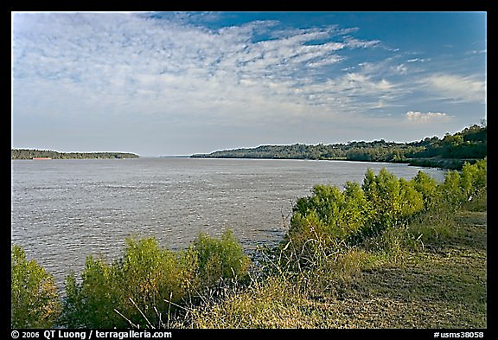
Mississippi river, just outside of Natchez, one mile wide
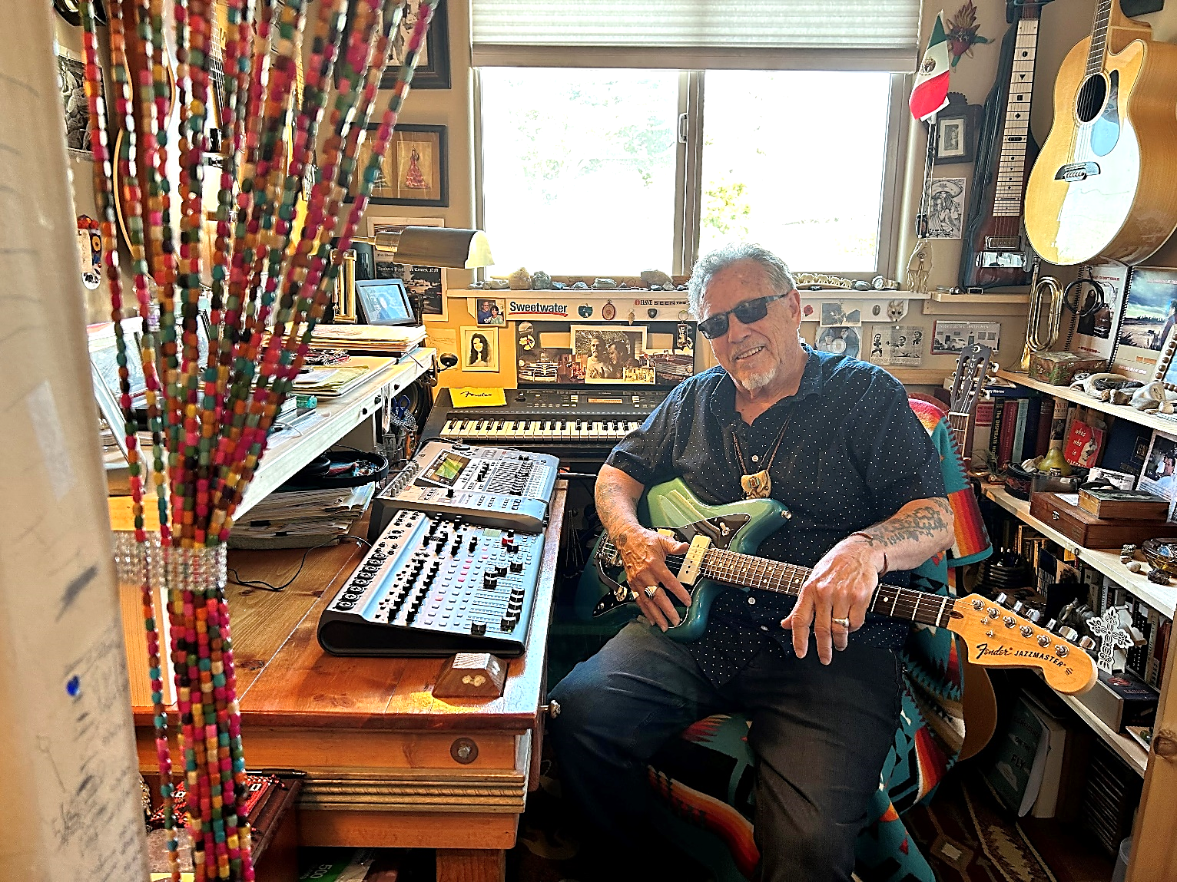
Recording Volume 14, Studio44. Not quite done... “but it’s gettin’ there”.
Photo – Carmen Madrid Wright

Song List
1. Long Lost Son ...................................................................................................5:28
2. When the Mountains Fall...................................................................................3:56
3. I Built My Own City..........................................................................................3:27
4. The End of the Street.........................................................................................4:00
5. Come on Home (Take a Load off your Mind)......................................................3:32
6. Anybody Like You.............................................................................................3:23
7. Make My Troubles Disappear (She)....................................................................5:11
8. As I Lay Down with You...................................................................................4:14
9. I’m Only Lying to Myself...................................................................................3:57
10. God Helps Those Who Help Themselves.............................................................4:02
11. In the Realm of Dreams (Reprise from Volume 7, 2017)......................................4:41

Rhythm in the Word, Copyright 2024 by Don Wright
donwrightmusic.com

