A Dangerous Time of Day
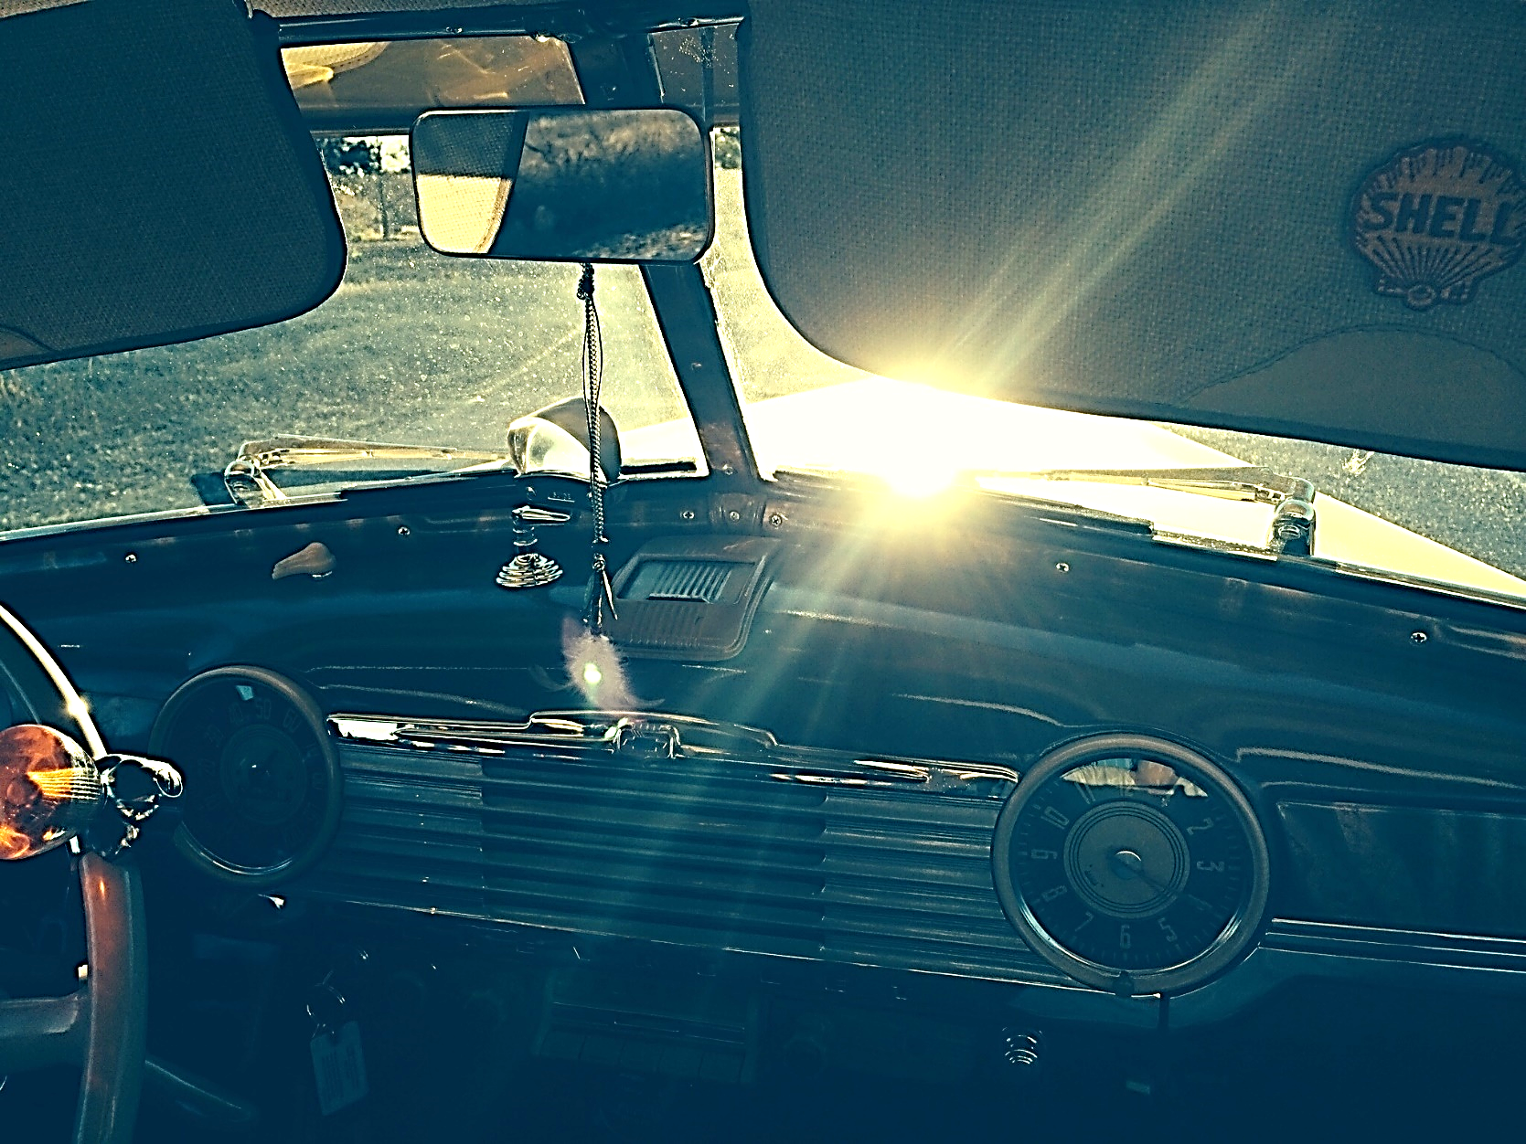
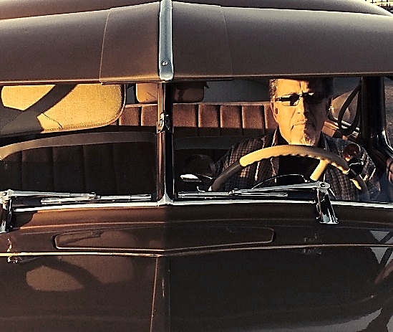

------Don Wright------
Rhythm in the Word – Volume 13
Home Recordings – 2023
A Dangerous Time of Day
Copyright 2023--------------------//------------------by Don Wright
Lyrics and music for all songs by DON WRIGHT
Vocals, guitars, harmonica, keyboards & mandolin – DON WRIGHT
Background vocals, tambourine & shakers – Carmen Madrid Wright
Recording and sound mixing done in the Closet Studio – Los Osos, California

“Watch and pray so that you will not fall into temptation. The spirit is willing but the flesh is weak.”
Matthew 26:41

Not every door is for walking through. Some are for looking in and walking away. We make choices on a daily basis – a choice between hope and desperation, or between forgiveness and revenge. I believe that what comes of those choices partly depends on the reasons we made them – whether purely a visceral reaction to satisfy ourselves or some loftier, moral pursuit in the name of sacrifice. On the one hand, I say if you live your life wholly in in the hope of a beautiful eternity, you just might be wasting your time here. If you think you know who or what God is, you’re a fool. On the other hand, if you think there is no God, you’re an even bigger fool.
D.W 13 March, 2023
“Oh the road is long and straight as a high wire”

I pulled into the parking lot of a motel along Route 66, just outside of Gallup, New Mexico one night, many years ago. I couldn’t tell you the name of it, these many years later. The ‘Vacancy’ sign was blinking and it was getting late and I was nodding off, dangerously. I cut the motor, went inside and hit the buzzer on the desk. A small, rumpled man came out, signed me up and took my money. “Room 44, all the way to the end,” he said. Which struck me odd since there appeared to be maybe a dozen rooms in all. I was too tired to make a discussion of it and headed in that direction, happy just to lay down and close my eyes without fear of running off the road and meeting my maker.

In the morning, as I was in that state of being not fully awake but not really sleeping, came a knock at the door. I put my pants on and opened it. It was you. “Your car was unlocked so I threw my bag in the back seat, you almost ready?” We headed east.

UP AND DOWN THIS HIGHWAY (I’m Your Lover Man) Copyright 2022 by Don Wright

I’m your lover man when the sun is shining
I’m your lover man when the day grows dark
I will run you up and down this highway
Until this motor runs down
Or just won’t start

Oh the road is long and straight as a high wire
Hard as the rock in the river bottom
Steady in my hand
And I will run you up and down this highway
Day and night oh yeah
‘Till we get to the end

I’m your lover man
When you need consoling
I’m your lover man
If you just need a ride
I will carry your water
And warm your bed at night
And you can walk through my door
When you need a place to hide

I’m your lover man when the sun is shining
I’m your lover man when the day grows dark
I will run you up and down this highway
Until this motor runs down
Or just won’t start
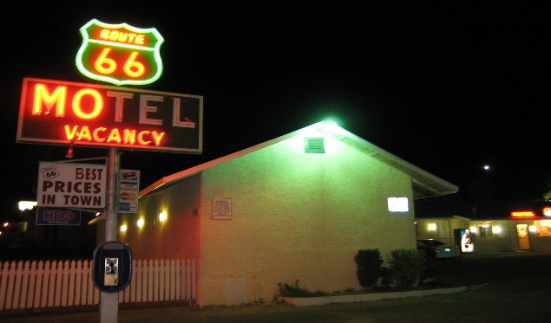
“You and I we had it once
Turns out once just wasn’t enough”

Breaking up. Making up. After a while I think you run out of ways to approach either one. I been married almost fifty years... just not to the same woman. There’s been a few of ‘em. Things always start out with the best intentions of course. Then you hit some low spots. Maybe you find a way to level out and justify being halfway satisfied or half-assed miserable. You do your best to fire things up when you can and you might bump along like that for a number of years.

But the rain always comes and, like they say, when it rains it pours.

KEEP A FIRE GOING Copyright 2023 by Don Wright

I’m gonna get in my car and drive away
I’ll be over you in maybe one more day
Yeah I know life is rough, ain’t that a fact
The only thing bad ‘bout leavin’ is comin’ back

Now I been mopin’ ‘round here for way too long
Hopin’ that somethin’s gonna change as time rolled on
Yeah you tell me that you want to be
Everything that I need
Guess there ain’t nothin’ you could say
Right now I wouldn’t believe

The wind is blowin’ me down the road again
Am I comin’ or am I goin’, y’know I can’t tell
You and I we had it once
Turns out once just wasn’t enough
To keep a fire goin’ or to start it up again
To keep a fire goin’ in the pourin’ rain

Come here baby and kiss me, tell me goodbye
I bet you can look like you mean it without even trying
Lately I been thinkin’
I might find myself somewhere
Somewhere I can live without you
Like I been living with you here

The wind is blowin’ me down the road again
Am I comin’ or am I goin’, I can’t tell
You and I we had it once
Turns out once just wasn’t enough
To keep a fire goin’ or to start it up again
You can’t keep a fire goin’ in the pourin’ rain

I’m gonna get in my car and drive away
I’ll be over you in maybe one more day
Oh I know life is rough, ain’t that a fact
Yeah the only thing bad ‘bout leavin’s
Gonna be comin’ back
The only thing bad ‘bout the leavin’ is the coming back
“I fear the horseman gonna be coming soon”

I saw an old man shuffling down the sidewalk on a walker, one very slow, short step at a time and I got to thinking about the Horseman – the one who’s coming for us all, at some point. The one you really don’t need to prepare for because there’s no need to present yourself in the way you’d like to be seen. Not with him. He knows and accepts the real you. Gotta give him credit for that at least.

But yeah, he’s coming and, on occasion, I think I can hear the hoofbeats – very faint, soft even, but steady.

TAKE ME AS I AM Copyright 2022 by Don Wright

I lay in the light
Of a full October moon
Listen to the waves
Breaking on the sand
I fear the horseman
Gonna be coming soon
Take me as I am
Out where the innocence was lost
There’s a native son
Holding fire in his hand
He calls out to God above
And everyone
Pleading, take me as I am
Take me as I am
As I live and breathe
Just as I am and nothing more
Or walk on and let me be

They say the trouble with life
Is by the time you learn
The years have come and gone
I say the trouble is
We got to find a way to see each other
Just for what we are
And there ain’t nothing in this world
We need to define
Nothing to understand
There’s flesh on the bone
And there’s ground under the sky
Now take me as I am
Take me as I am
As I live and breathe
Just as I am and nothing more
Or walk on and let me be
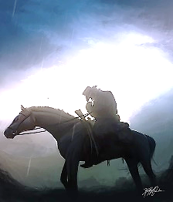

”There’s no way out that I can see
Other than to give in to the thing that tortures me”

It seems simple in the morning. All things are possible. Lessons have been learned from the day before and I’m not going to repeat the same mistake(s). As the afternoon matures and the shadows lengthen, and the sun lowers itself into a position where I feel the need to draw down the shade, things always return to a predictable outcome. A script I am familiar with. To the point of surrender.

I used to fight with myself. But we all fade down the stretch.

A DANGEROUS TIME OF DAY Copyright 2022 by Don Wright

This is a dangerous time of day
‘Cause I get to feel like drinkin’
When I do I can’t remember
What it was I should do
When I get to feeling
Like I want to be with you

It’s a dangerous time of day
And I don’t know what I was thinkin’
It has become the way I’m used to
There’s no way out that I can see
Other than to give in to the thing that tortures me
Oh it’s a dangerous time of day

Every morn at break of day
Feels to me like hope is on the way
But the peace that never comes
Fades beneath the brightness of a merciless sun

This is a dangerous time of day
When my mind begins to wander
Faces rise out of the shadows
As the light grows ever dim
And I welcome the despair that closes in
Oh it’s a dangerous time of day
A dangerous time of day

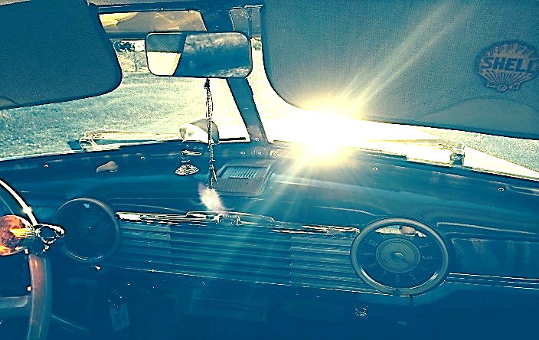

“Night would roll in with the fog
And the lights of town would call”

There was an earthquake in 1969, in Santa Rosa, California, about sixty miles north of San Francisco. The ground jumped and the streets rolled like swells in the ocean. People were left with broken homes and some, homeless. Buildings caught fire, gas lines ruptured and water ran in the streets. People got scared and left town, moved on and looked for a way to make a living elsewhere. I headed south – to a place made famous by an earthquake, my birthplace, San Francisco. Go figure.

I was in that house that flew off its foundation. But this story isn’t completely true... The store was on Divisadero Street.

CADILLAC Copyright 2023 by Don Wright

It was 1969, I was living on the edge
I bought me a Cadillac, a 1958
Times were rough but things were cheap
We managed to survive
Whenever I was feeling low
I’d take that Cadillac and drive

There came a time the earth it shook
One California night
This old house we were living in
Jumped five feet to the right
Loaded up that Cadillac
With everything I owned
Headed down the coast to the Frisco Bay
Burnin’ up the road

I got a job pumping gas
A dollar and a half an hour
And a room down below the street
With a hot plate and a shower
Night would roll in with the fog
And the lights of town would call
I’d slide into my Cadillac
And we’d begin our crawl

I met a man with a shifty smile,
A shotgun and some weed
We got high and we robbed a store
On 22nd Street
The clerk came out from behind the counter
With a pistol in his hand
We jumped in that Cadillac
As the bullets went flying past

That was a long time ago
I think I learned my lesson well
Stay away from guns and dope
And always look out for yourself
That Cadillac’s still sittin’ out in the yard
But it don’t run
I just sit behind the wheel
And remember when we had our fun

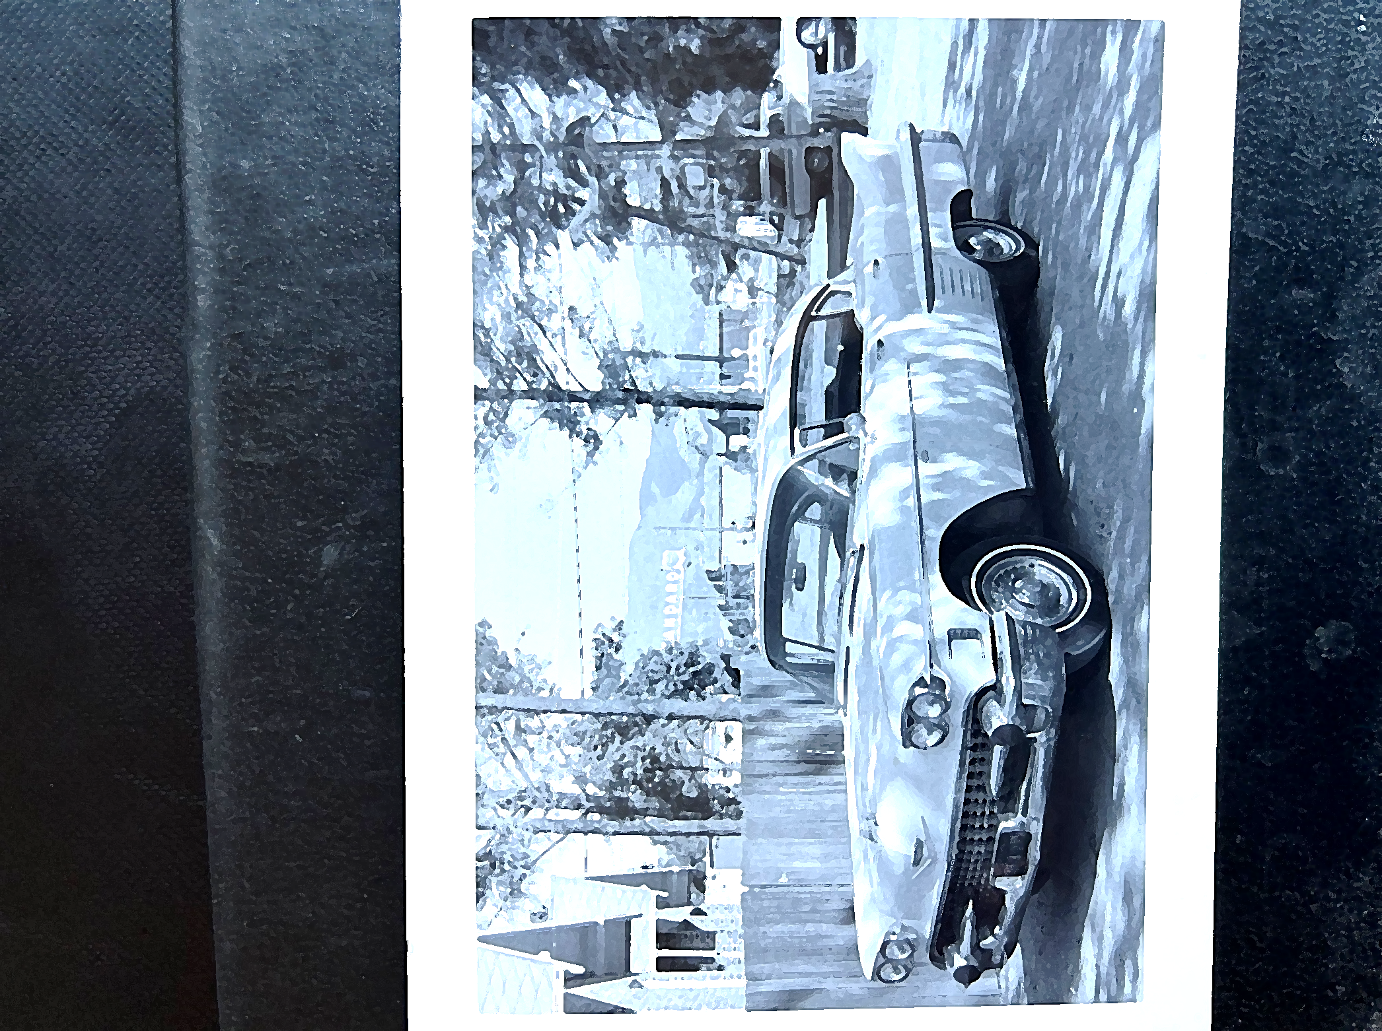
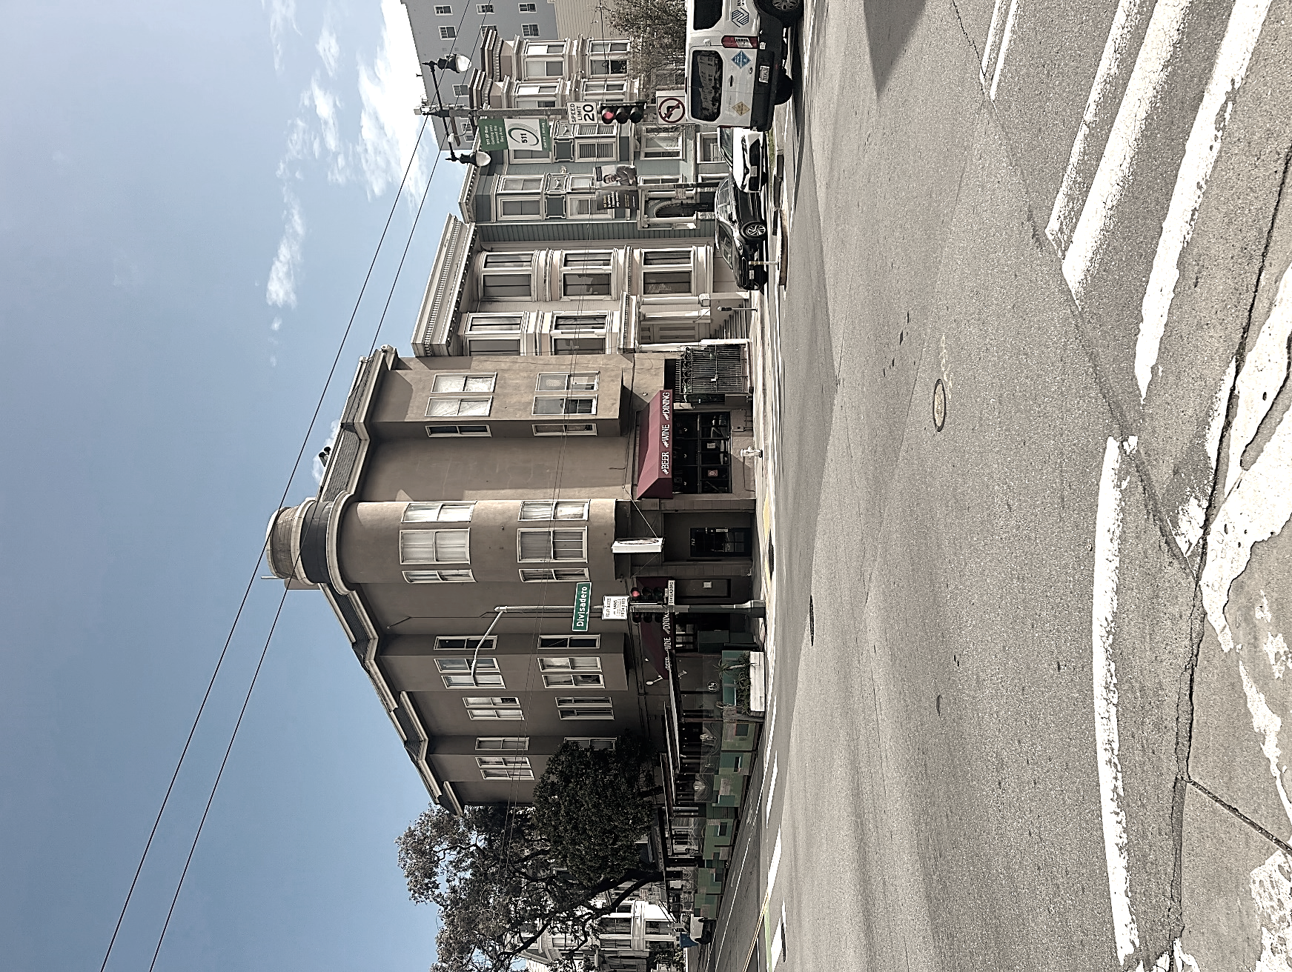
“You got somethin’ in ya, needs to come out”

I knew a medicine man from Montana, used to camp along the Little Big Horn river when he was a boy. He said that’s where he got his medicine and first felt the calling. He ended up in California and progressed into being pretty much a drunk more‘n anything else. Good man though and knew a few tricks about curing a few things.

He worked on me a couple of times.

THE DOCTOR TOLD ME Copyright 2023 by Don Wright

Well the doctor told me
You better get your mind right
Try walkin’ on the other side
Of the street

He said, son you ain’t lookin’ too good
In my professional opinion
You got somethin’ in ya
Needs to come out

That’s what the doctor told me
Then he turned and left the room
Left me to contemplate my doom
All alone on the table

The doctor told me
Y’ know you got to stop drinkin’ so much
You’re slippin’ down and losin’ touch
With the light of the world

He wrapped me up in a linen cloth
And began to wail and chant
Circled ‘round me in a crazy dance
And looked to the sky

Then it began to rain
All day and all through the night
And all the while I’m wrapped up tight
‘Till the sun come up

And the doctor told me
You can find your own way now
I’m movin’ on to another town
Just remember what I said

That’s what the doctor told me
You got to get your mind right
Keep walkin’ on the other side
Of the street

” Is it in the moonlight or on the wings of a dove?”

What is real? Only that which you can hold in your hand? Or see with your own eyes? Is friendship not real? Or sadness? Or love? Of course, it all gets left behind in the end – real or imagined and everything in between. While we live and while we search for answers and fulfilment, it seems important that we see things clearly and that we aspire to know the difference between reality and bullshit. Or between obedience and devotion. But... I see no difference between the physical and the spiritual. Too often we cast one aside for the other whereas, truly, they cannot be separated. Every living thing and every ordinary day possesses the heartbeat of all creation.

Our visions and perceptions are not always precise. And reality is not always truth.

TRUTH Copyright 2023 by Don Wright

I don’t know where the truth comes from
Could be the wind that I hear howling in the night
The only time it feels like I maybe found some
Is when I was looking in your eyes so clear and bright
It’s not in the tales that I’ve been told
Not in the dream or the lure of the road
I don’t know where the truth comes from

There’s no one on your side, the truth be told
And what is waiting ‘round the bend’s a mystery
I know I was young and I know now I’m old
And I know there’s a rider
Who waits out there for me
Long as I’m standing on this ground
I believe in everything I found
But I don’t know where the truth comes from

I don’t know where the truth comes from
Maybe it’s just in the sound
And the smell of a summer rain
Is it in the moonlight or on the wings of a dove
Or in the tears on a bed
Where my love and I have laid
Of a time that seems so long ago
Across the border in Mexico
And I don’t know where the truth comes from

I don’t think it matters anymore
Whether there’s an answer or there ain’t
When the time has come to look behind the door
I won’t be surprised if I hear someone say
“Take my hand and come with me
We will see what we shall see”
I don’t know where the truth comes from

It never ends or didn’t you know
It’s just a stop along the way for a traveling show
I don’t know where the truth comes from

“I guess we all got to live with some kind of danger”

“You staying out of trouble?” When I get asked that in casual conversation, my answer always is, “It’s my top priority.” Well, priority or no, of course things happen. I mean, I’ve done pretty well overall, I’d say. Some are drawn to trouble. Seems they find it exciting, I suppose. That’s not me – I’m drawn to the quiet places. I’m comfortable in the shadows. I haven’t been in a fistfight since the eighth grade and I’ve stayed out of jail for the last forty years. Still... I know it’s out there, waiting for an opportunity.

TROUBLE FINDS ME (Wherever I Am) Copyright 2023 by Don Wright

Some people live in the shadow of a volcano
Some are living just below the dam
I guess we all got to live with some kind of danger
Trouble finds me wherever I am

I knew a man with a fast motorcycle
He used to ride it as hard as it could go
I’d just follow behind, take my time
No need to hurry
But trouble still found me
Face down in the middle of the road

Trouble always finds me when I ain’t looking
And I lay low whenever I can
I stay away from the evils of temptation
But trouble still seems to find me wherever I am

I like to think that I mind my own business
I’d like to think that you think you should too
Yeah that’s what I thought but now I know
What the answer is
Trouble’s gonna find me even if I do

Trouble always finds me when I ain’t looking
And I lay low whenever I can
I turn away from the face of temptation
Trouble still gonna find me wherever I am
Wherever I am

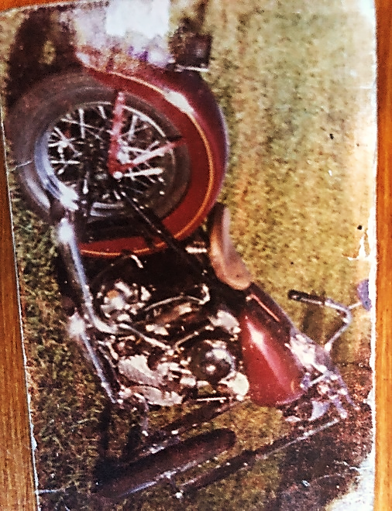
“The sun is low, the moon’s coming up
Don’t waste your time thinking too much”

This road doesn’t end anywhere. There’s always another direction to turn. And I’ve come to think, looking back, that, much of the time, flipping a coin would have served me as well or possibly better than weighing the options thoughtfully. Looking back, that is. Looking ahead, I probably won’t be flipping any coins – it’s not in my nature – but just between you and me, it is a bit of a crapshoot, isn’t it?

CHOICES OF A TRAVELER Copyright 2023 by Don Wright

When you come to where the road breaks off
And you got to choose one way
It seems like it’s just one or the other
But there’s a lot of ways to play it
So take your time but don’t take too long
In the end you’ll find there’s no right or wrong
Just give it some gas
And head on down the road

Don’t look back, leave it all behind
Pull over to the side and rest your mind
And wait – just wait for the traveler’s sign

Down at the bottom of a long old hill
Where the country opens up
Keep on rolling and look for the lights of town
The sun is low, the moon’s coming up
Don’t waste your time thinking too much
Just give it some gas
And head on down the road

Don’t look back, leave it all behind
Pull over to the side and rest your mind
And wait – just wait for the traveler’s sign

You got to keep on moving
Yeah we all know that
It’s just a matter of how far
Wandering through the desert
Or following a river to the sea
Your only fear is running out of time
Whether you’re running in the day or in the night
Just keep that foot on the pedal
And head on down the road

Don’t look back, leave it all behind
Pull over to the side and rest your mind
And wait – just wait for the traveler’s sign
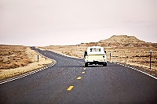
“The bees make the honey and the Devil made gin”

There is a phrase in Spanish – La Madrugada. Directly translated, it means ‘the dawn’. How it’s most commonly used however, especially in song, is to describe that period of an hour or two before the sun breaks over. The period of time when it’s always possible the sun will not rise. Or that, when it does rise, things will have changed. Is it reassuring - that final part of the turn that brings us back to the light of day? Or is it a reminder of the shrinking number of the ones we have left? Both, I expect.

While most are asleep, I am generally awake during this time, clear-headed and contemplative and resolved to making the most of things.
Then the sun comes up.

4:44 IN THE MORNING Copyright 2023 by Don Wright

Shadows are waiting in the wings
To trace any light the dawn brings
When that mockingbird sings
At 4:44 in the morning

The bees make the honey
And the Devil made gin
I got no one to blame for the shape I’m in
When I come crawlin’ in
At 4:44 in the morning

Even in a world gone wrong
‘Round midnight if you hear this song
You know that it won’t be long ‘till the morning

Now we’ve come a long way my friend
Never worried what’s around the bend
To let it all end at 4:44 in the morning

Look out that window, walk out that door
I tell you I just don’t know what to think anymore
I’m down on the floor
And it’s 4:44 in the morning

Now I’m looking for a place to hide
And let this temptation blow by
We’ll see what rolled in with the tide
Come morning

Time is precious or so they say
Time is wasted when you wish it away
God bless this day!
It’s 4:44 in the morning
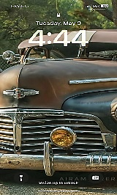
“I been drowned and rescued every time but one”

I was standing out on the third-story deck of an old Victorian flat in Frisco some years back, talking with a friend and easing ourselves into the late afternoon, sharing a joint. Clouds rolled in and it started raining in a matter of minutes. The houses in this neighborhood all abutted their property lines, stacked one next to the other and we were directly across from the slate roof of the house next door. You know how, when you see lightning, the thunder comes a few seconds later and you can tell how far away it is – about one mile per second, right? Well, the loudest crack of thunder I ever heard was right then and right at the same time a bolt of lightning crashed into that slate roof, not ten feet from where we were standing, sending several tiles broken and scattered across the roof and onto the deck where we stood and some over the edge onto the ground. Needless to say, it startled us somewhat. We headed inside.

I got to thinking about the randomness of nature. Actually, wondering if it really was all that random. I mean, how could it be? Isn’t there an order to the universe? I’ve come to think it’s got to be about the most ordered thing there is and that somehow every bit of it is intentional. If you got struck by lightning and survived, you might consider yourself singularly unlucky. (Or lucky in that case) You might wonder how you could be the victim of such an arbitrary act of nature.

If it reaches out and whacks you again, you can stop wondering.

LIGHTNING AND RAIN Copyright 2023 by Don Wright

Did you see that lightnin’
Well here comes the rain
Fallin’ down on me
They told me lightning
Couldn’t strike me again
I guess we’ll see

Every time there’s a storm
Yeah we run for cover
Wait ‘till it blows on by
Stay huddled inside
Look out for one another
‘Till we go back outside

Well it don’t rain but that it pours
Always that way it seems
I don’t mind wading out in the water
It’s the lightnin’ scares the hell out of me

I been drowned and rescued
Every time but one
Only God knows why
Darkness descended
And the thunder rolled
Lightnin’ split the sky

And I went rollin’ with the tide
And I sang loud and clear
“I believe in you”
Seven days and seven nights
And I wound up here
Healed through and through
Well it don’t rain but that it pours
That’s always been my way
I’ll walk this road
Until I get to the end
That’s all I got to say

Do you see that lightnin’
Here comes the rain
Fallin’ down on me
I was told that lightning
Couldn’t strike me again
Well I guess we’ll see

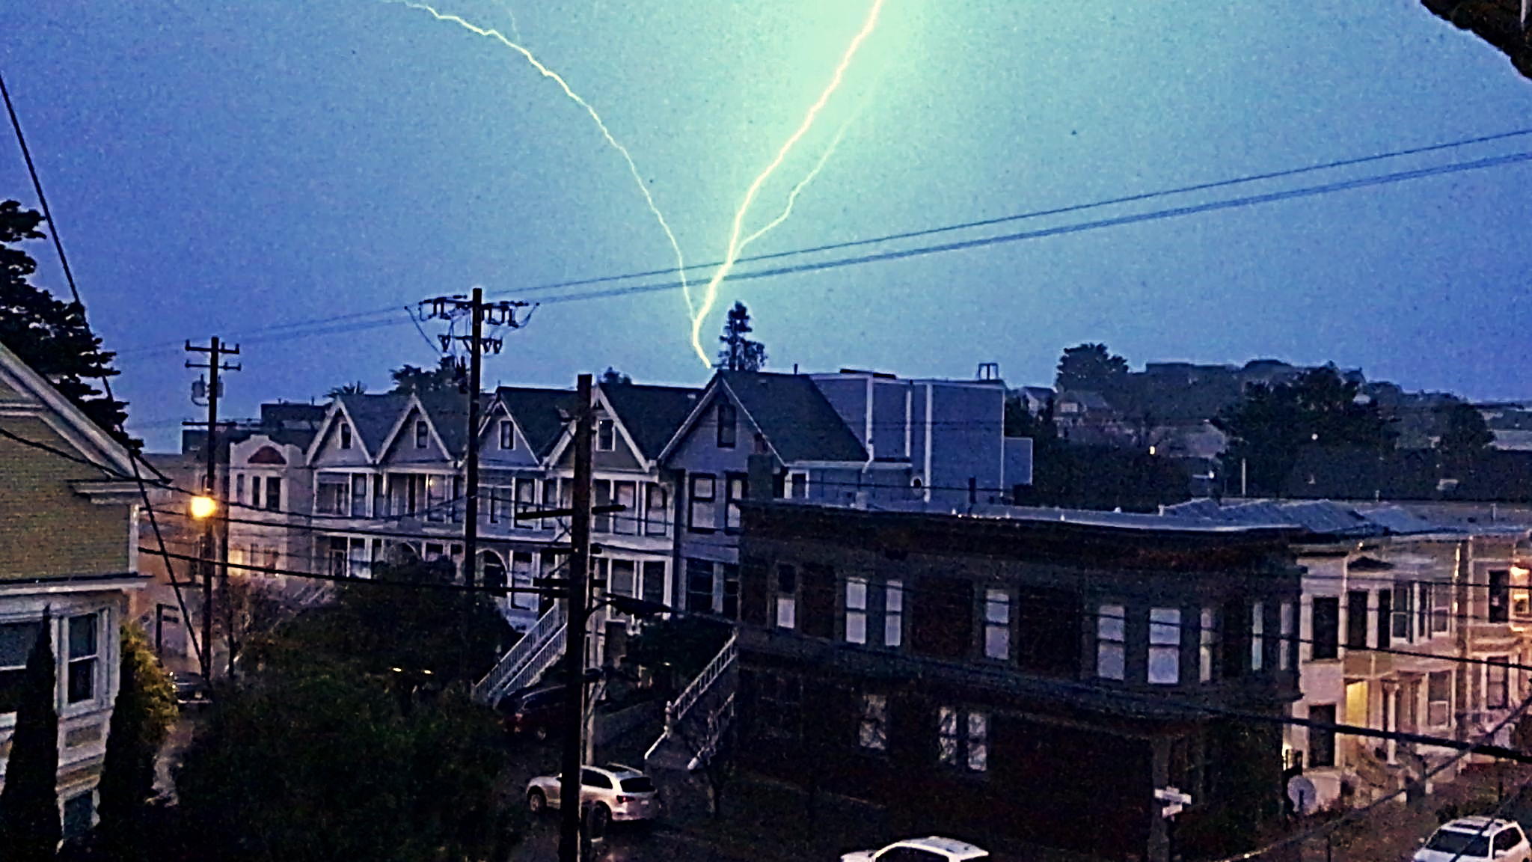

The earth rolls over It begins with the sound of a baby crying
I see it tumbling slowly through the darkness Ice cubes dropping into a glass
Spinning at 25,000 miles an hour Car tires pulling in on a gravel driveway
And we don’t feel a thing Promise and expectation
We watch the sun move across the sky
And the ever-changing patterns It ends with a screen door slapping
Of all those other suns and planets Wind blowing across an empty porch
In the vault of the heavens at night Hank Williams song fading out on the radio
Way out there... And a resignation to uncertainty
Just like we are

“Maybe I’ll come back this way sometime”

Two people headed in the same direction might never meet. But two people traveling the same road in opposing directions are bound to meet up (unless they’re headed away from each other, I guess). He was looking for answers. She was running away from answers to the questions she had asked. And from what she thought she wanted. They were about to give up on both endeavors when they happened upon each other. Just as well, I’d say – she was headed back to where she started out and he was sure to be disappointed because everybody knows Paradise ain’t all it’s cracked up to be. I hear they’re happy now, somewhere in the middle.

PARADISE Copyright 2023 by Don Wright

She was standing by the water
She was talking to herself
Lost in casual conversation
Like there was someone else
“Don’t try to talk me out of this,” she said
“I just got to go”
“Maybe I’ll come back this way sometime,
I don’t know”
She looked across to the setting sun
And waved a quick goodbye
Then set off down the road
Away from Paradise

He was looking for a kind of faith
Like he had before
He had walked down every street
And he had opened every door
The truth is just a step away
He always told himself
“I can’t get lost if I just keep my eyes
Wide open,” that’s what he said
He didn’t know what was waiting for him
But he’d find out in time
And he headed up the road
That goes to Paradise

Day turned into night like it does
Night turned into day
He found to his surprise
So many twists and turns along the way
And she had second thoughts herself
About the road that she had chosen
Whether sleeping or awake
The same unsettling dream played over
They were both thinking ‘bout turning back
As they came around a bend
And met up on the road
Between here and Paradise

He felt a fever rising up
Somehow she felt it too
Before too long she touched his hand
She asked him what he thought they should do
He knew in his heart there was something going on
Unspoken though it was
And as daylight fell and the moon appeared
He took her in his arms
They left the road and headed out
Across the empty plain
Somewhere between here and Paradise

I hear they were last seen
Walking together hand in hand
Somewhere between here and Paradise

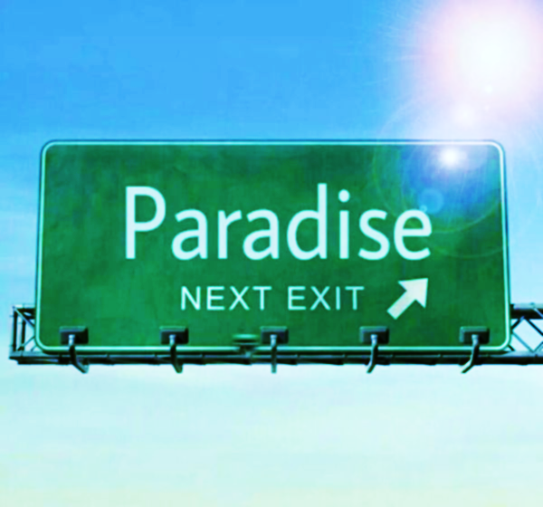
Arriving in Paradise

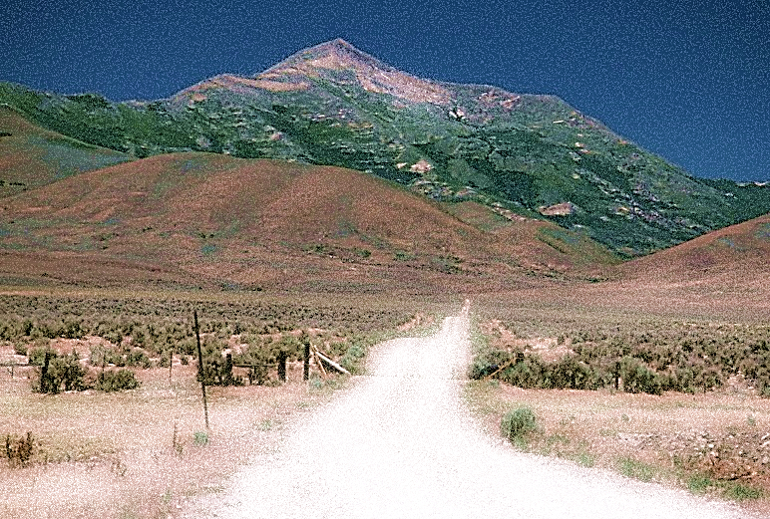
Leaving Paradise

I remember a time of expectation
And winds that swept across the low land
And the rain that never fell
Familiar faces looked to the sky
Faces that normally were intent
On other things
That were now turning pale
From a loss of hope
From a loss of faith
In things usually taken for granted
Nothing should ever be taken for granted
Not water or light
Not the sun rising or the world turning
Not love
Or the mystery from which it is born



Trace my body on the window glass
As I stand here with open arms
Waiting for your touch
If you detect subtle movements
Of the eyes and mouth
It is only because I expect
Something will come of this
That I may not be prepared for
I fear there may be an upheaval of sorts
A sudden and terrible storm
Or a wreck on the highway
The earth will tremble
And the sky grow dark
And time will stop its ticking down
If for some reason...
You do not see me here
Someone Shot the Bank Manager (cont. from Volume 12)
“Theodore Lyle Rupert, age 29, was found with a fatal gunshot wound to the chest and was declared deceased at the scene, behind the First Western Savings and Loan yesterday. No suspects are in custody and no leads are being discussed by the Natchez Police Department.” So read the report in the Natchez Democrat on Saturday, March 16, 1980. Louie Grayson set the paper down on the breakfast table and looked out the window of his mother’s house in Old Town, Natchez, where he still resided at the age of 28.

He looked out the window but saw nothing of whatever was out that window. His mind’s eye was filled with thoughts of Teddy. And of Brie Louise McDaniel. He’d known both of them all his life. Teddy, from the ‘other’ side of Natchez, had become a friend over the years. Not in the usual way. Not through school or sports or riding bicycles through the neighborhood. It wasn’t until after high school that they would attend the same junior college, Natchez being one of the slowest cities in the state to finally integrate the school systems. But Lana Rupert had been employed by the Grayson’s in domestic service. Had even lived on the premises for much of that time, along with Teddy. And when Teddy got old enough, he became an employee too – taking care of the grounds and landscaping mostly. They had grown up together as friends, like any other two boys would be – within the confines of the Grayson property that is.

And Brie, well Brie Louise, as he preferred to call her, was just about the most perfect example of feminine perfection he could imagine. And had always been. They lived just a block apart and the families knew each other well and socialized on a regular basis. He recalled the time she told him, at seven years old, that she was going to marry him when the time came for such things. That sounded fine to him then and the thought of it being just fine had never diminished.

But Brie always had a soft spot for Teddy too and as they got older, she grew ever fonder of his dark eyes, his dark skin, the smell of him, even the way he spoke – slowly, thoughtfully. There was a sadness about him and a strength at the same time. And there was the exotic nature of the contrast.
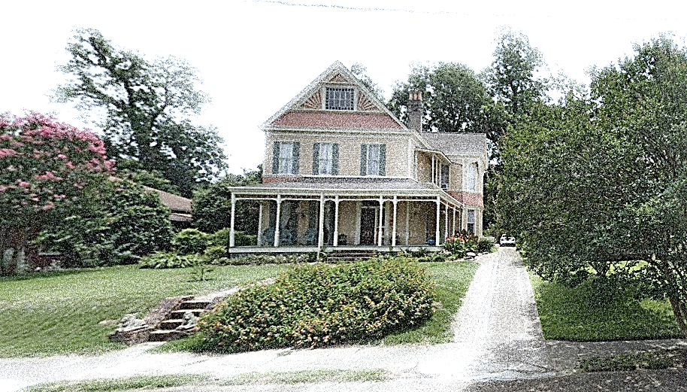
Grayson Residence, North Pearl Street, Natchez, Mississippi
So there came a day when she gathered up the nerve within herself to just come out and say it. She felt he must have known it was coming - and he did. She caught him coming out of the bank one day and asked him might he want to take lunch with her, down at the park. She had some barbeque and polk salad in a basket. She was given no argument.
“Do you know how I feel about you?” She asked, after they had sat down and set the lunch in between them.
“I... believe I do,” Teddy said haltingly and with a resignation filled with both fear and desire.
“Well I do, I just do! And I have for a long time and I just don’t care who knows it!” She exclaimed, almost shuddering.
“You know how I feel about you too, Breezy,” he sighed and took her hand to comfort her. She got up and came around to the other side of him on the bench and they embraced, fully and without shame.
“I just don’t care anymore,” almost in tears, she said and buried her face into the base of his neck, “I love you!”
“I love you too, Breezy. I pretty much always have. Lord, I don’t know what we’re gonna do.” She straightened up and took a deep breath and blessed him with the biggest smile he ever could recall of hers.
“We’re gonna get married is what we’re gonna do,” she said softly, as she touched her hand to his face and kissed him fully on the mouth. (to be cont.)
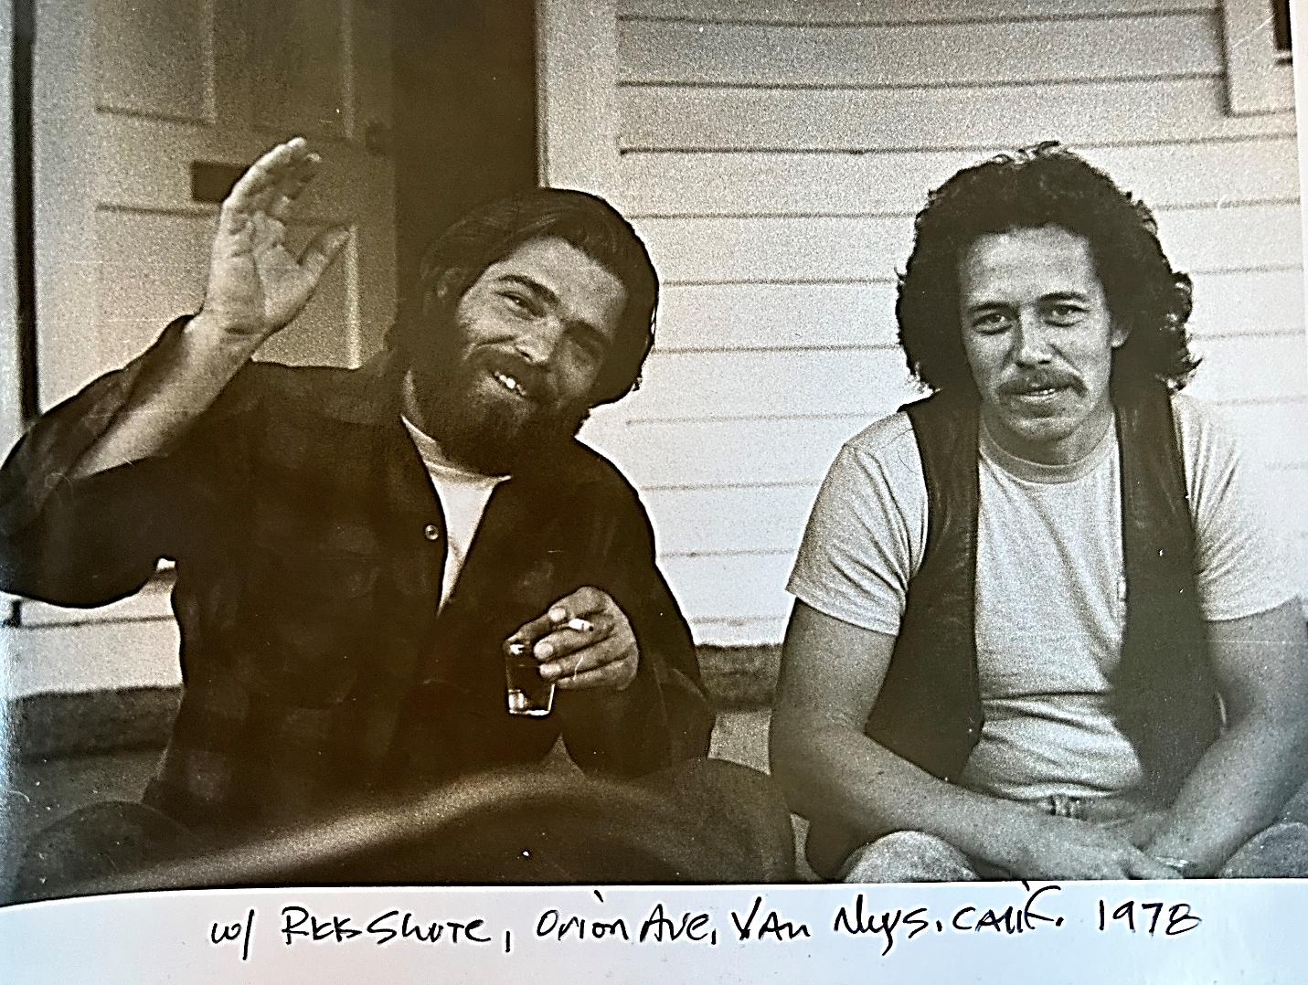
With Rick Schute, Orion Avenue, Van Nuys California, 1978

Song List
1. Up and Down This Highway (I’m Your Lover Man) ..........................................4:27
2. Keep a Fire Going...............................................................................................4:25
3. Take Me as I Am.................................................................................................3:20
4. A Dangerous Time of Day..................................................................................3:22
5. Cadillac.................................................................................................................4:24
6. The Doctor Told Me............................................................................................4:08
7. Truth.....................................................................................................................4:58
8. Trouble Finds Me (Wherever I Am)...................................................................3:39
9. Choices of a Traveler............................................................................................3:38
10. 4:44 in the Morning............................................................................................3:36
11. Lightning and Rain...............................................................................................3:14
12. Paradise.................................................................................................................6:09

Rhythm in the Word, Copyright 2023 by Don Wright
Donwrightmusic.com

