B E T H L E H E M
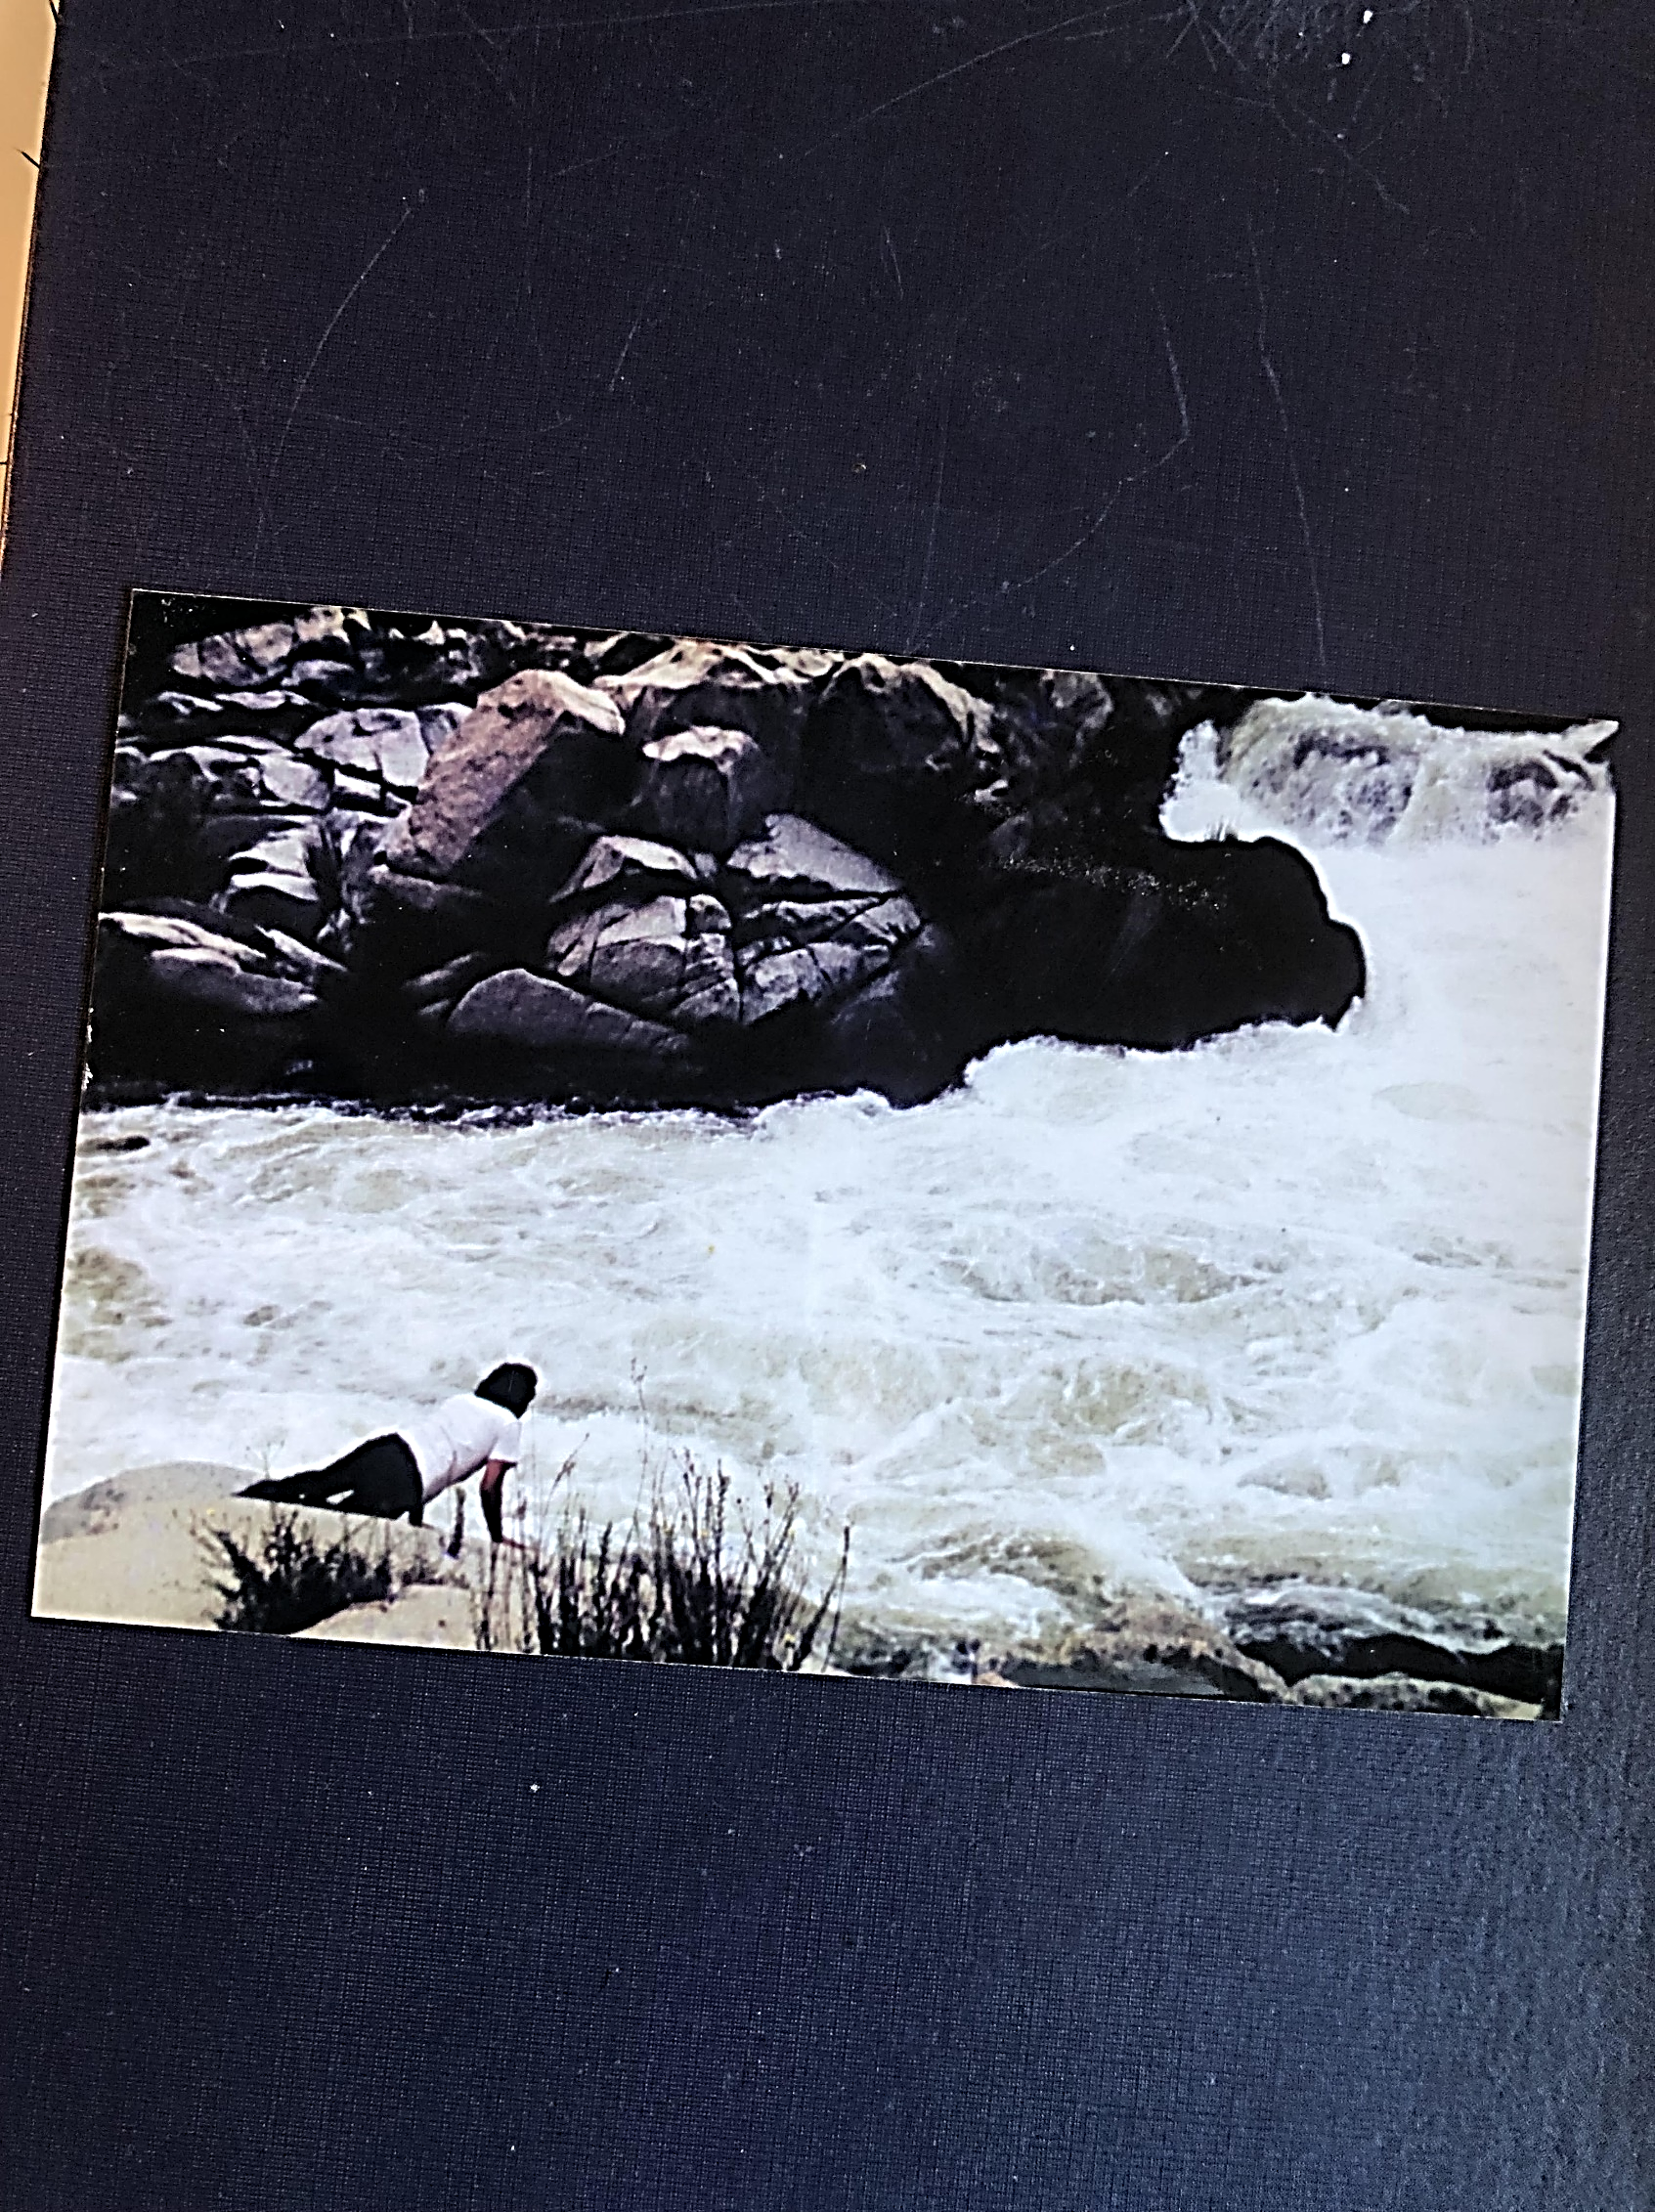
Don Wright
Rhythm in the Word – Volume 12
Home Recordings - 2023
B E T H L E H E M
Copyright 2023------------------------------//----------------------------by Don Wright
Lyrics and music for all songs by DON WRIGHT
Vocals, guitars, harmonica, keyboards & mandolin – DON WRIGHT
Background vocals, tambourine & shakers – Carmen Madrid Wright
Recording and sound mixing done in the closet studio – Los Osos, California

Somewhere between Thomas Wolfe’s Look Homeward Angel, where he talks of “..new magic in a dusty world” and William Butler Yeats’ The Second Coming – “A gaze blank and pitiless as the sun,” this album was born. I read The Second Coming during my short year and a half in college and Look Homeward Angel about three years later in a Colorado jail. That’s been some fifty-plus years gone now and I finally got around to putting them together for a variety of reasons.
Wolfe wrote of Pennsylvania. Yeats ended in Bethlehem. The title of the album and the song aside, this album is about neither directly. It’s mostly about maybe the sound of wings, or trains rolling endlessly across the American plains, trouble hidden in places that cannot be seen, shelters from the trauma of everyday life, salvation and dignity in the common man. And kingdoms of heaven that have come and gone and may yet come again.
Bethlehem, in the Holy Lands, is the birthplace of Jesus. Bethlehem, Pennsylvania is the birthplace of American steel. These two seemingly disparate places and times, devoid of any obvious connection, are nonetheless equal in my mind, as spheres of contemplation that drove the writing of the title song and the others that inexplicably followed. As it comes, it goes. And as it was, it is.

“And what rough beast, its hour come round at last,
Slouches toward Bethlehem to be born?’ --William Butler Yeats – The Second Coming
...” Rolling like a holy thunder across the plain tonight”
West. Seems it’s always been the way to advance a civilization. Or escape servitude. Or just get away from your problems. Maybe to start a new life. Something about following the sun and slowing down time. If you’re traveling under your own steam, so to speak, well that’s one thing. But if you’re waiting on a ride, well... these trains never seem to run on time, do they?

MY TRAIN’S COMING Copyright 2022 by Don Wright
Out west is where I’m going
To feed this hunger I feel
Where the sun is setting
On a deep blue sea tonight
My train’s coming
My train’s coming

They say it’s a land of plenty
Plenty enough for us all
Don’t bring nothing
You can’t afford to lose or give up
My train’s coming, coming in
My train’s coming
My train’s coming, oh oh
It’s coming in

Standing at the station, suitcase in my hand
Mark my destination any untrodden land
I hear the rumble and the...

Whistle of the mighty engines
Calling from far away
Rolling like a holy thunder
Across the plain tonight
My train’s coming
My train’s coming

Now when you feel it down in your bones
It’s something you can’t deny
Whether it’s a brand new morning
Or the middle of the night my friend
My train’s coming, coming in
My train’s coming
My train’s coming, oh oh
It’s coming in

My train’s coming
My train’s coming
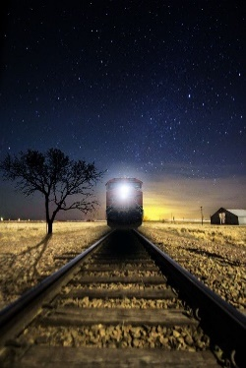
...“I’ve been a prisoner of the wilderness”

There are times when the noise is so loud it drowns out everything and you see mouths moving but no sound coming out. Then there are times, if you are straining to hear the softest of things, the most precious of things, well all else fades away – thunder, traffic, or any other of the useless cacophony of the world. And nothing matters but a heartbeat. One other than your own.

THE SOUND OF WINGS Copyright 2022 by Don Wright

Tell me where I can find you after you have left my sight
Tell me where you’ll be when you’re not with me
When the moon comes up in the morning
Or when the sun goes down at night
It’s only real with your heart beating here beside me

And even though it travels like a fog inside my mind
I can still see clearly that you’re troubled
Come and go as you see fit but don’t leave me behind
I’ve fallen under the flood and I can’t rise above it

I don’t hear the sound of thunder rolling in
I can’t hear the bells above us as they ring
Surrounded by a silence in a world defined by you
All I can hear is the sound of wings

I have crossed too many oceans
Driven down too many roads
To find myself now captive to your wishes
Yet here I stand before you bereft of any will
Holding onto little of my senses

So take me where it is you go, do with me as you will
I don’t care whatever becomes of me
I’ve been a prisoner of the wilderness
Now fallen to my knees
Nothing’s gonna change the way I feel

I can’t hear the message or the messenger
Or the prophecy of ruin that he brings
Covered by a mantle of obsession
All I can hear is the sound of wings

I don’t hear the sound of thunder rolling in
I can’t hear the bells above us as they ring
Here beneath a leaden sky that’s closing in
All I can hear is the sound of wings



...” Hidden in each blameless shadow
And in every rock that rolls”

Well, well, well, don’t you know it ain’t that thing you see comin’ at you that you got to worry about? If you can see it coming, you have a chance to fend it off, figure out a way to handle it, come up with a plan.
It’s that thing that, all of a sudden’s got you by the collar and you can’t even get turned around enough to see what it is. Yeah that’s the one that’ll get you. That’s the one you better watch out for. Somehow.

LAND OF UNSEEN TROUBLE Copyright 2022 by Don Wright

Like a deer in the forest
Looking out from tom behind every tree
Like the lion in the jungle
Stepping so soft and quietly
In a land of unseen trouble
There is danger to behold
Hidden in each blameless shadow
And in every rock that rolls

And when I found me a woman
Who swore that I was the one
I told her all of my secrets
And give her the key to the vault
In a land of unseen trouble
You never know what one might do
Come out from behind the curtain
And cut you right in two

Now when you step out your door in the morning
Or when you stumble in late at night
You better count your blessings
On your fingers and toes
Grab your baby and hold on tight
In a land of unseen trouble
All is lost of whatever is found
So don’t take nothing you can’t live without
And keep both feet on the ground

There’s a shark in the water
With his mouth wide open all the time
Stay away from those things that beckon
To your senses and your weakened mind
In a land of unseen trouble
You can’t trust even what is known
All your messes and all your worries
Will catch up with you down the road

In a land of unseen trouble
Something’s always following you
Hiding in the darkness and the light of day
And in everything that moves
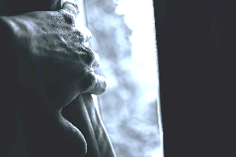
...” Oh I’ll meet you on the other side of the hill”

Things aren’t always just what you’d expect – we wouldn’t really want them to be, would we? And I’ve learned that, if we’re ever going to find that something we seek, there are times we have to suspend our expectations of what is believable. To know ourselves, to fall in love, to feel at peace with whatever this thing (life) is, requires a leap of faith. And leaps of faith start with a step and end up we know not where.

WHERE THE MOON WENT DOWN Copyright 2022 by Don Wright

Out where you see that road rolling on
Out past the end of town
There is a place we just might fall in love
Out where the moon went down

You might find me looking off somewhere
In a dreamy reverie
It’s just that I’m imagining someplace I’d rather be

Oh I lie awake sometimes at night
And I can hear the sound
Of a lonely old coyote crying
Where the moon went down

As the whole world waits for the sun to come up
And to start all over again
I think of you and I wonder if we’ll ever
Want this tender night to end

Beyond the light and the stars coming out
In between the dusk and the dawn
Oh I’ll meet you on the other side of the hill
Where the moon went down

I’ve been walking these streets so long
Forgot the reason why
You came around the corner and with one look
That’s when I realized

Everything is just a wish away
We only need to turn around
And run to the horizon so we can see
Where the moon went down

Yeah there’s a place we could fall in love
Out where the moon went down

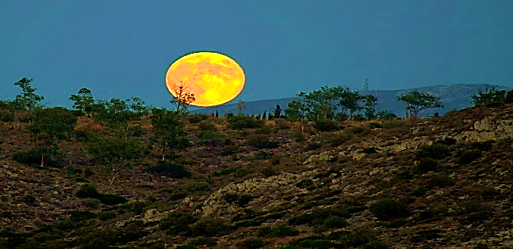
...” But who am I to be on this road?”
“I feel weary,” she said. “So weary.”
“Weary. What kind of word is that?” I asked her. “You mean tired?”
“I’m worn out, run down. Don’t think I can go on. Something’s got ahold of me and won’t let go. I just feel
so weary.”
“So, more than just tired?” I asked.
“Yeah. More than tired,” she sighed.

WEARY Copyright 2023 by Don Wright
I am weary, oh so weary
I am lost and alone
When my mind tells me one thing
But my heart leads me on
It just makes me weary
Of a world gone wrong

They tell me walk to the light, straight away
Take his hand, do not stray
But who am I to be on this road
Carrying the weight of a heavy load
It makes me weary
Of the things I’ve done

See that moon shining down on the water
Sure makes me want to come right
But don’t I know that when the sun is rising
I’ll be running for a place to hide

See that moon shining down on the water
Sure makes me want to come right
But I know when that sun is rising
I’ll be looking for a place to hide

Can you tell me one thing I don’t know
I wish you would but I don’t think so
It’s just from what I’ve seen, it all comes ‘round
Time and again from town to town
And I’ve grown weary
Oh so weary, I am weary
I got nothing left to leave behind

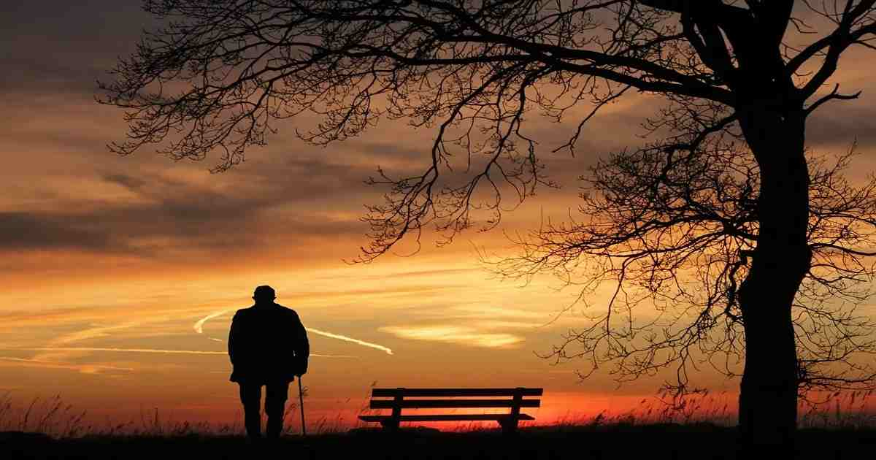
...”someone not to be mistaken for the likes of anyone else”

There is no shadow without light. And there is no hope without despair. We must find comfort in who we are alone. But there is no me without you.

BOX OF SHADE Copyright 2022 by Don Wright

I knew a man who lived in a box
Lived in a box of shade
Had many friends who came and went
But none ever did stay
Yeah people came from all around
To see his box of shade
But when the night began to fall
They would make their getaway

There was a time that he was young
This man with the box of shade
Just the same as anyone
He had his brighter happy days
But on and on the years rolled by
Sure as the world does spin
Slowly he did build
His box of shade to live within

One day a woman knocked on the door
And introduced herself
As someone not to be mistaken
For the likes of anyone else
This box of shade will do just fine
She said as she crossed the room
Kicked off her shoes, pulled up a chair
And stayed the whole night through

Well in the morning he opened the door
Said she was free to go
But she demurred with a smile on her lips
Said, “I don’t think so”
The sun was coming up outside
On a brand new shiny day
They closed the door and went right back
Inside their box of shade

I knew a man who lived in a box
Lived in a box of shade
I knew a woman who lived with a man
Who lived in a box of shade

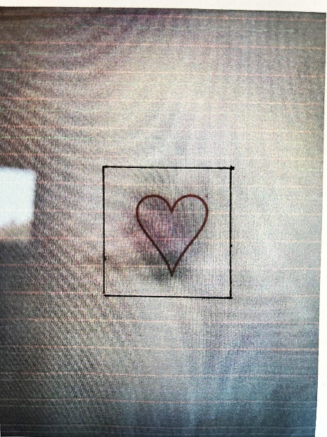

...”dignity comes in small doses
But each one is a thing to behold”
What are we left with when we lose everything? Well the answer seems, at first, obvious - nothing. But, of course, what you have left is what you started with – yourself. Your singular, precious, miraculous self. And there are people in this world (a miracle of its own) who have decided it is their purpose in life to recognize the beauty and dignity of each of us and provide a way back, to restore those of us who need restoring... these are the angels who walk among us.

TIJUANA SHELTER Copyright 2022 by Don Wright
In the rain of a Mexican morning
He came carrying all he had left
Walking down Avenida Aldama
To the door of Casa de Merced

Inside with the walls now around him
He laid down his burden of shame
Was given a blanket of honor
And called once again by his name

They say dignity comes in small doses
But each one is a thing to behold
You can’t judge what you’re worth by another
Or know a story before it is told

She was bruised and left to stand in the window
Looking out at the town she once knew
Knowing that she no longer belonged there
And knowing there was nothing left to do

So she moved from one man to another
With nothing to share but regret
Until she found Avenida Aldama
And the door to Casa de Merced

They say dignity comes in small doses
But each one is a thing to behold
You can’t judge what you’re worth by another
Or know a story before it is told

So they both thought they needed salvation
They both had a reason to run
When they found one another unguarded
On a morning laid bare by the sun

And they found a common way to forgiveness
Found a way to start over again
Alli’ en Avenida Aldama
En la Casa de Merced

They say dignity comes in small doses
But each one is a thing to behold
You can’t judge what you’re worth by another
Or know a story before it is told

...”And who will I be without you, I don’t know”

I guess I’ve always pictured it as blue, that place we’ve all been told about since we were kids. Probably has something to do with the suggestion that it was somewhere the other side of the sky. Funny how things stick with you even when you get beyond the age of believing everything you’re told. Makes it a little more complicated when you have to pick and choose.

HEAVEN’S BLUE LIGHT Copyright 2022 by Don Wright

This rain falling in this town
I’ve grown tired of watching it come down
Feels like we’re all gonna
Slide off into the ocean
And sail out o’er the sea

And what will you do when I go
And who will I be without you, I don’t know
Comes there a time to cross over
But will we both be there
To stand in heaven’s blue light

This old road I’ve been down before
It just makes me melancholy all the more
I never rode to the end
But I see it comin’
Sure as that sun going down

There’s something in this western wind
Keeps me wandering back here again
I hope we never get lost
Or ever stop wanting
To stand in heaven’s blue light

I’ve packed my bag, I’ve rosined my bow
Dropped it in gear and I’m flying down low
Don’t wait for me to come ‘round
No just get yourself ready
And stand there in heaven’s blue light

We’re gonna look like the sun
Coming up over the mountain
Standing there in heaven’s blue light


...”what I wanted remains unchanged
Just enough and nothing more”
I have come to realize, at seventy-four, the good fortune that I have had. It has not been an easy ride. I’ve not been given much and I’ve not taken much. I’ve made mistakes and I regret them. I’ve made money and spent it all. I should have died or been crippled in a motorcycle accident some forty years ago, yet still I walk about. My life has been an affirmation of a mystery. I am now comfortable with the mystery.

FORTUNATE MAN Copyright 2022 by Don Wright

Contentment in troubled times
And hope when all seems lost
A breath of wind to carry me home
These many seas across

Where I was and where I am
Doesn’t really matter much
But who I am is a fortunate man
Giving thanks and taking none

And what I wanted remains unchanged
Just enough and nothing more
If I could only stand on the ground
Where my father stood
In the land where I was born

Here as I lie awake
Well before the break of day
Counting every heartbeat
Waiting for a world that won’t
See the truth and turn away

Now if there is one thing I understand
You cannot be what you are not
I know I am a fortunate man
Living by the grace of God

And living out a life of ease
I wouldn’t know about
What I do is what I please
Sometimes that’s taken me down

I have looked out on the morning of the brightest day
I have seen the darkest night
I’ll tell you what I am, I’m a fortunate man
And happy just to be alive

Where I’m going, well I ain’t going far
And what there is to do I’ve done
Who I am is a fortunate man
Giving thanks and taking none

Yeah that’s all I am, I’m a fortunate man
Giving thanks and taking none

...” He wants to be told the truth, so he says”

From what I can tell, I don’t think Jesus would ever give up on humanity. But I wouldn’t say the same for God. I could see Him throwing up His hands and saying, “Figure it out. I gave you so many chances!”

Or something like that.

I DON’T BUILD KINGDOMS Copyright 2022 by Don Wright

There’s a man in the doorway
Come in out of the rain
He’s got a lot to lose, very little to gain
He’s here to find out which way to turn
And just how far he should go
He wants to be told the truth, so he says
But I don’t know
And what he’s told isn’t what
He expected to hear, oh no

Walk away, straight down that road
Take what you’ve seen
Take what you’ve sown
Just walk away, no maybe run
I don’t build kingdoms anymore
I’ve had my fun

Confused and frustrated
Disappointed and blue
Everything he believed ended there
In that darkening room
He said he wanted the truth
But the truth was not what he desired
And as he pleaded and moaned
About what he was told
Came the answer again the same as before

Walk away, straight down that road
Take what you’ve seen
Take what you’ve sown
Just walk away, no maybe run
I don’t build kingdoms
Those days are done

And where the mountains meet the sea
You’ll find everything you need



...”I see the shadow of a trembling hand”
I dreamed of a desert. And it started raining. Rivers formed where there were none before. Bushes grew on the banks and lakes appeared at the foot of the mountains. As the rain let up, the sun moved between the receding clouds and shadows covered and uncovered me. I walked. I swam in the rivers. Once, in the distance, I saw a figure (may or may not have been a man) beckoning me come. I went. The figure disappeared over a low hill and when I reached the crest and looked down into the lowland, there was no one to be seen. I continued in that direction and discovered, after some distance I do not recall, a tattered garment caught on a bush. A longish cloak, or shawl of sorts, weathered to some degree. It smelled of flowers and musk, both of a type I couldn’t say.

I wrapped the shawl around my shoulders and walked on. After some time – which may have been days, it’s impossible to tell in a dream – I entered a town. There were no people in the town. It was an old town of squat adobe buildings, dirt streets. Something back in time. At the end of the one street, sat a man on a low rock wall. He had loose pages, torn from a book, in his hands and was looking through them. When I approached, he looked at me and slightly smiled. “You’ve brought my coat,” he said. “I’ll take it now, it’s getting cold. I thank you. These are for you.” And he handed me the pages. I could not read them no matter how hard I tried. Couldn’t make out the words but felt certain that they contained what must have been an important message. The man left without discussion, with the cloth wrapped around him and barefoot.
When I woke, early, it was still dark but I couldn’t get back to sleep. I put on my pants and slippers and a heavy sweater and went out in the yard. I sat down under one of the Mulberry trees on a wooden crate I used for a bench and retrieved the bottle of Mexican brandy from within, along with a shot glass. I waited for the sun to come up. Leaning with my back against the tree, after a period of time, I fell asleep. And dreamed of a desert.

BETHLEHEM Copyright 2022 by Don Wright

I tried and I tried and I tried
I failed and I didn’t know why
One step forward and two steps back
Looking out the window
Or looking through a crack in the wall
Where the Israelites fled
You always wanted me to be myself
I couldn’t have been anyone else
Now I wake up just where I fell
It’s dawn in Bethlehem

There’s something cookin’ out in that kitchen
It’s been sittin’ on the stove all night
I’m waiting or that pot to come ‘round
And give me the strength to pick myself
Up off the ground where I lay
Among a swarm of lies
I see the shadow of a trembling hand
Reaching out for anyone it can hold onto
I’ve heard he’s on his way
Now he’s here in Bethlehem

I’ll take the blow where I stand
I’ve bowed down as much and as far as I can
So hear these words from my tongue
I am what you made me and you are the one
Who said there’d be nothing to fear
When the messenger comes

Every now and then I think I see
Something coming ‘round the bend
The ground starts shaking and the sun goes dark
The choir starts singing and the waters they part
Just like it says in Exodus
I climbed the mountain and I came back down
Looking for something that couldn’t be found
They say it’s buried at the bottom of a well
Somewhere in Bethlehem

I’ve run from the desert to the sea
And every mile was like the one before
I’ve seen innocence perish
And I’ve seen the blood
I walked through fire
And I swam through the flood
I can tell you think it’s still not enough
A blue light shines down on everything
Darkness falls as the belltowers ring
And the people are all gathered as one
On the streets of Bethlehem

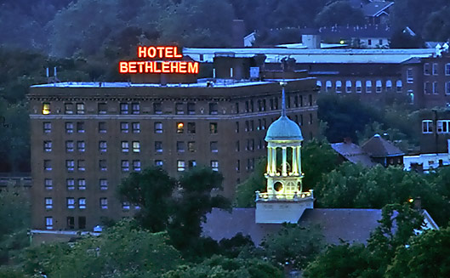
“I bring you with reverent hands, the books of my numberless dreams”
W.B. Yeats

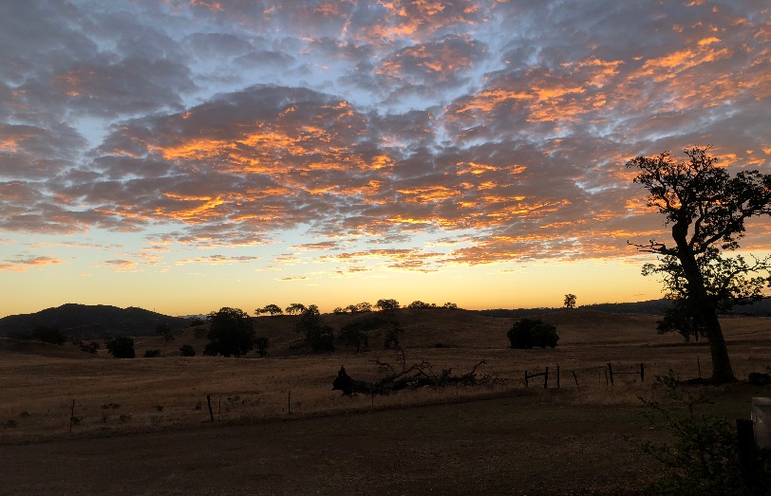
Morning, Estrada Ranch
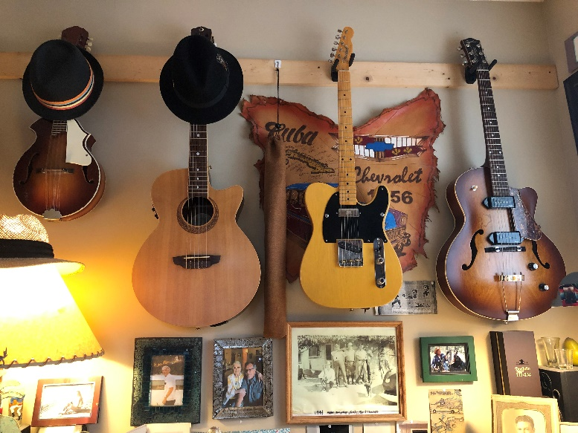
Studio, Los Osos
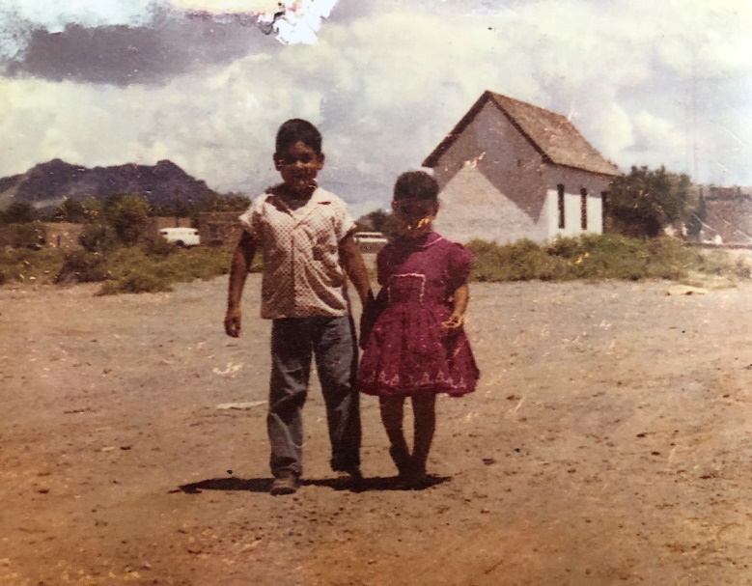
Manuel y Carrmelita, Dona Ana
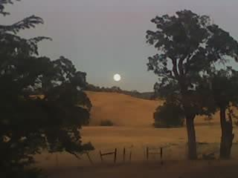
Evening, Estrada Ranch

Someone Shot the Bank Manager (cont. from Volume 11)
A fireball come down in the Mississippi river. No one else claimed to have seen it, but he did – Louis Grayson. The sky lit up like it was daytime, but for no more than a second. The rain came shortly thereafter and the river swole up and pushed against the banks all in a matter of an hour or so. Louie couldn’t say exactly what the hell it was but it was to him, at once strange and remarkable and unexplainable, yet left him with the feeling that he’d seen it before. It happened while he was taking a long walk in the afternoon, trying to clear his head and make sense of what had occurred the week before at the First Western Savings and Loan in Natchez...

Quite a large crowd had gathered at the entrance to the parking lot where Teddy Rupert now lay in a slowly spreading puddle of his own blood, covered with a Natchez PD-issued blanket. The county coroner had arrived to oversee the transport to the county office and officially determine cause of death, though that cause was obvious to all, what with the bullet hole through the breast pocket. They backed the coroner’s wagon in and loaded him in it, then slowly made way through the parting crowd out into the street and on downtown. The bank custodial crew was called in to clean up the pavement.

Lana Rupert, Teddy’s mother, had just been told of his death by detective Tillotson, who she only happened to know because of Brie McDaniel. Tillotson had not the common courtesy or respect to escort Lana into the house to deliver the news. He broke it to her across the fence, wherein she instantly collapsed and he had to carry her inside. As she later emerged momentarily from a fog of unbearable grief, her thoughts migrated to Brie and of the Rose Hill Baptist church, where Brie was one of only three white members. She would have to begin planning a service. A service that would only magnify the tension in the congregation and the fretfulness she had been experiencing ever since Teddy and Brie had begun seeing each other. Without regard to custom. (to be cont.)

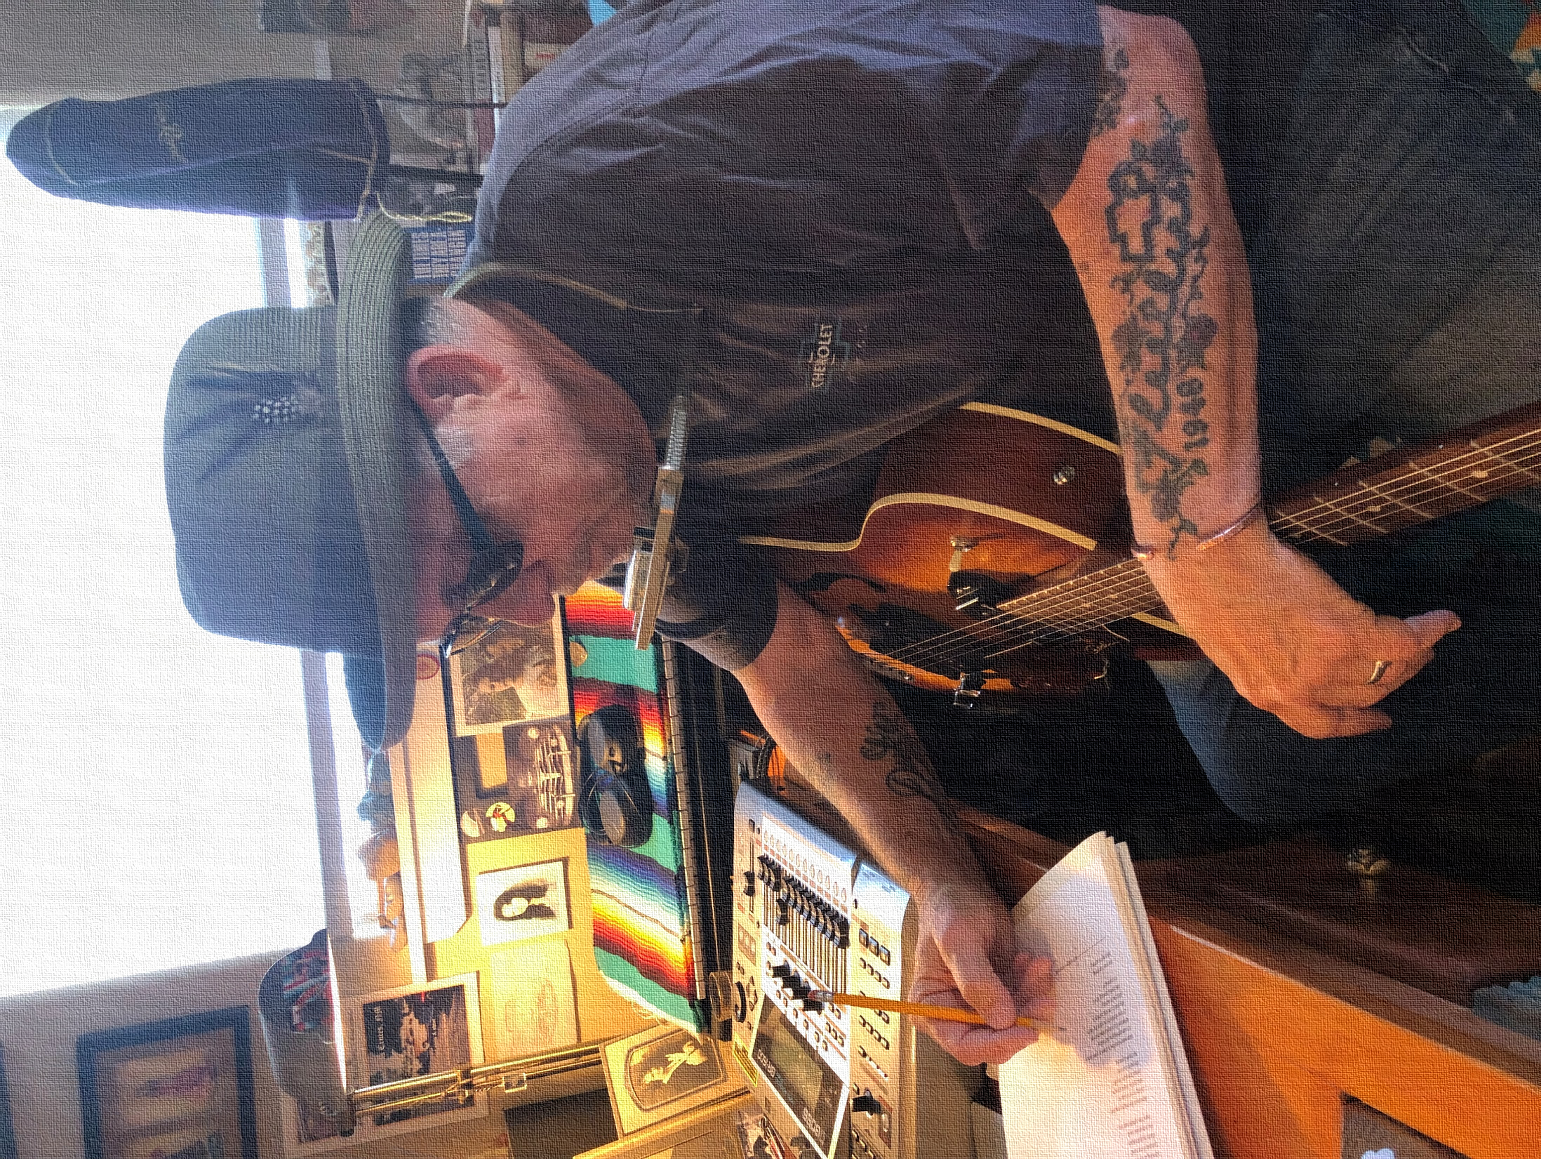
BETHLEHEM TITLES

Track Track
1. My Train’s Coming.......................................4:50 7. Tijuana Shelter..............................................4:10
2. The Sound of Wings.....................................3:49 8. Heaven’s Blue Light......................................3:54
3. Land of Unseen Trouble..............................3:56 9. Fortunate Man...............................................4:49
4. Where the Moon Went Down.......................3:20 10. I Don’t Build Kingdoms.................................4:44

5. Weary...........................................................3:54 11. Bethlehem.....................................................5:27
6. Box of Shade................................................4:02
Front cover photo by Al Delmartini (Kern River, where it comes out of the mountains, east of Bakersfield, 1974)
Back cover photo by Lucille Rose Webb (While recording Volume 12 in the Closet studio, Los Osos)

RHYTHM IN THE WORD, Copyright 2023, DON WRIGHT
donwrightmusic.com

